Jenkins 2nd page 10 tasks

Tag: Jenkins Pipeline

>> Difference Between Agent and Node in Jenkins Pipeline

You're right. The previous version mixed article theory, our implementation, and extra explanation in a way that wasn't clean enough. Here is the accurate version based only on the Baeldung article you shared and what we actually implemented.

Task 1 — Difference Between Agent and Node in Jenkins Pipeline

1. Jenkins Pipeline
A Jenkins Pipeline is a series of automated steps used to build, test, and deploy an application.
A Pipeline consists of:
- Stages — logical sections of the Pipeline.
- Steps — actions performed inside a stage.
- Agent — defines where the Pipeline or a stage runs.
- Node — a Jenkins machine that executes Pipeline tasks.

2. Agent
An agent in Jenkins defines the location/environment where the entire Pipeline or a particular stage is executed.
An agent can be defined:
- At the Pipeline level
- At the stage level

Common agent options covered in the article
agent any
Runs the Pipeline on any available Jenkins node.
agent none
Does not allocate a node for the Pipeline globally.
agent {
label 'agent-1'
}
Runs the Pipeline/stage on a node having the specified label.

3. agent any
agent any tells Jenkins to run the Pipeline on any available node.

Example
pipeline {
agent any

stages {
stage('Build') {
steps {
echo 'Building...'
}
}

stage('Test') {
steps {
echo 'Testing...'
}
}
}
}

Our implementation
We used:
agent any
Jenkins selected the:
Built-In Node
Both Build and Test stages executed there.

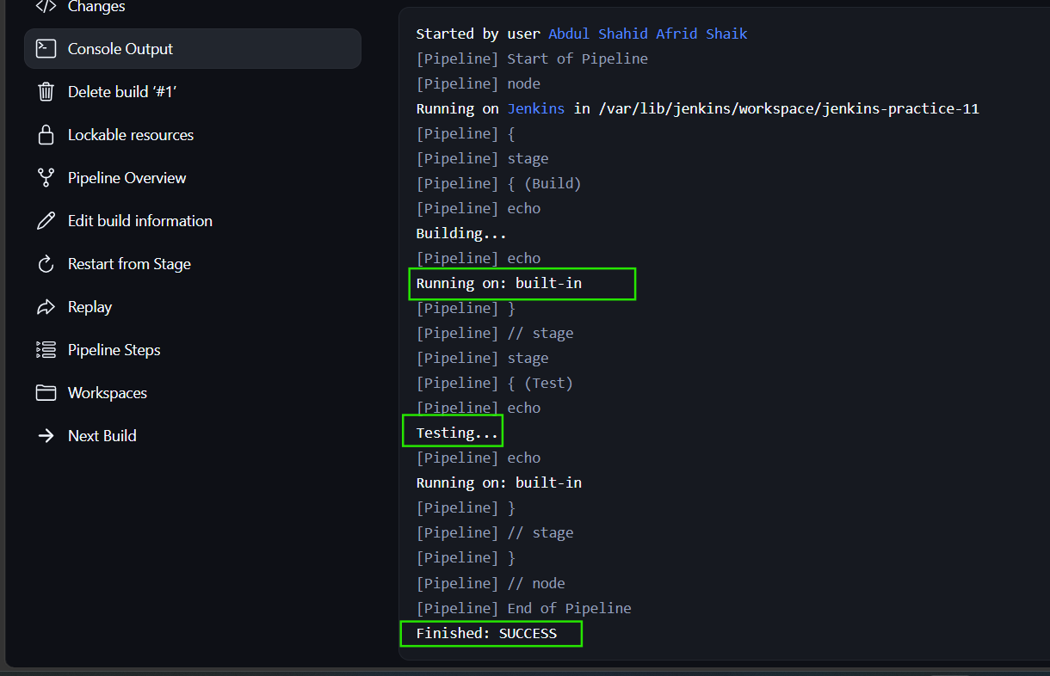

4. Stage-Level Agent
An agent can be assigned to an individual stage.

Example
pipeline {
agent any

stages {
stage('Build') {
steps {
echo 'Building...'
}
}

stage('Test') {
agent {
label 'agent-1'
}

steps {
echo 'Testing...'
}
}
}
}
Here:
agent any
is the Pipeline-level agent.
But the Test stage has:
agent {
label 'agent-1'
}
Therefore, the Test stage runs on a node having the agent-1 label.

Our result
Build → built-in
Test → jenkins-agent-1
This demonstrated that different stages of the same Pipeline can execute on different nodes.

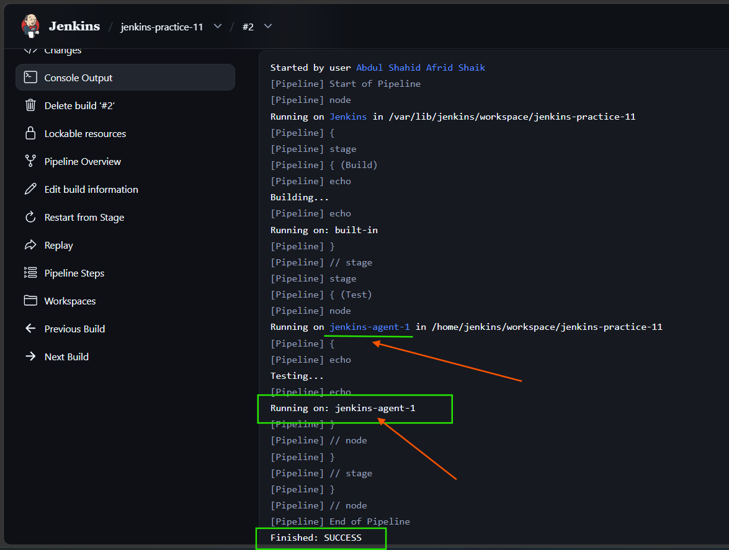

5. Node
A node represents a physical or virtual machine that is part of the Jenkins infrastructure and is capable of executing Pipeline tasks.
In the Jenkins architecture, the controller schedules and manages work, while nodes execute the work.
Our Jenkins environment contains nodes such as:
Built-In Node
jenkins-agent-1
jenkins-agent-2

6. Node Characteristics
According to the article, important characteristics of a Jenkins node include:

Labels
Labels are tags used to identify or group nodes based on their capabilities.
Example:
agent-1
A Pipeline can use this label to select the appropriate node.

Workspace
The workspace is the directory on the node where Jenkins executes the job and stores its files.
Our agent workspace was:
/home/jenkins/workspace/jenkins-practice-11

Executor
An executor represents the capacity of a node to run Jenkins tasks concurrently.
For example:
0/1
means the node has one executor and it is currently free.

7. agent none
agent none means the Pipeline does not have a global agent.

Example
pipeline {
agent none

stages {
stage('Build') {
steps {
...
}
}
}
}
When using agent none, individual stages can define their own execution environment, or a node can be explicitly allocated using node().

8. Using node()
The article demonstrates explicitly allocating a node using a node() block.

Example
pipeline {
agent none

stages {
stage('Build') {
steps {
script {
node('agent-1') {
echo 'Building on agent-1...'
}
}
}
}
}
}

Meaning
node('agent-1')
tells Jenkins to allocate an available node with the agent-1 label and execute the enclosed steps there.

Our result
Running on jenkins-agent-1
Building on agent-1...
The Pipeline completed successfully.

9. Agent vs Node
 | Agent | Node
Meaning | Defines where a Pipeline/stage runs | Machine that actually executes the work
Scope | Pipeline or individual stage | Jenkins infrastructure
Usage | Declarative Pipeline configuration | Can be explicitly allocated using node()
Example | agent any | node('agent-1')
Selection | Can select nodes using labels | Has labels, workspace and executors

Simple difference
Agent defines where Jenkins should execute the Pipeline or stage; Node is the actual Jenkins machine that performs the execution.

10. Practical Implementation
We implemented the following from the article:

Example 1 — agent any
pipeline {
agent any

stages {
stage('Build') {
steps {
echo 'Building...'
echo "Running on: ${env.NODE_NAME}"
}
}

stage('Test') {
steps {
echo 'Testing...'
echo "Running on: ${env.NODE_NAME}"
}
}
}
}
Result:
Build → built-in
Test → built-in

Example 2 — Stage-specific Agent
pipeline {
agent any

stages {
stage('Build') {
steps {
echo 'Building...'
echo "Running on: ${env.NODE_NAME}"
}
}

stage('Test') {
agent {
label 'agent-1'
}

steps {
echo 'Testing...'
echo "Running on: ${env.NODE_NAME}"
}
}
}
}
Result:
Build → built-in
Test → jenkins-agent-1

Example 3 — agent none with node()
pipeline {
agent none

stages {
stage('Build') {
steps {
script {
node('agent-1') {
echo 'Building on agent-1...'
}
}
}
}
}
}
Result:
Build → jenkins-agent-1

11. Key Takeaways
- A Pipeline contains stages and steps.
- An agent defines where a Pipeline or stage executes.
- agent any uses any available node.
- A stage can have its own agent using a label.
- agent none removes the global agent allocation.
- A node is the actual Jenkins machine that executes the work.
- Nodes can have labels, workspaces, and executors.
- node('agent-1') explicitly allocates a node with the specified label.
- Different stages can run on different Jenkins nodes.

>> Reading a File From Workspace in Jenkins Using Groovy

Task 2 – Reading a File From Workspace in Jenkins Using Groovy

1. Jenkins Workspace
A Jenkins workspace is a dedicated directory on the Jenkins agent where the build takes place. Jenkins automatically creates or updates the workspace when a build runs.
The workspace can contain:
- Source code
- Build artifacts
- Files required during the build
In our practical, the workspace was:
/var/lib/jenkins/workspace/jenkins-practice-12

2. Simple Groovy Script
Groovy can be used inside a Jenkins Pipeline using the script block.
Example:
script {
def message = "Hello from Groovy!"
echo message
}
This prints:
Hello from Groovy!

3. Reading a File Using readFile
readFile is the Jenkins Pipeline step used to read the complete contents of a file from the workspace.
Example:
def content = readFile 'example.txt'
echo "File content: ${content}"

Practical implementation
First, we created the file:
sh 'echo "Hello from Jenkins Workspace" > example.txt'
Then read it:
def content = readFile 'example.txt'
echo "File content: ${content}"
Output:
File content: Hello from Jenkins Workspace
Build result:
SUCCESS

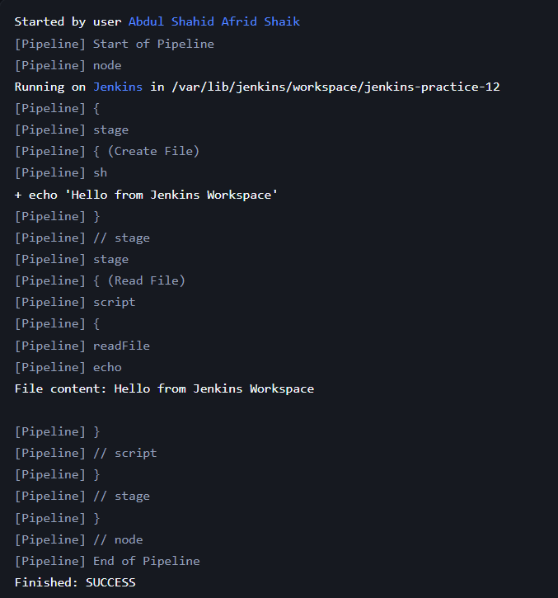

4. Reading a File Using Groovy File Class
The article demonstrates reading a file using:
def file = new File('example.txt')
def content = file.text
echo "File content: ${content}"
In Jenkins Pipeline, direct File operations were restricted by the Script Security sandbox.
We approved the required signatures and then used the workspace path explicitly:
def workspace = pwd()
def file = new File("${workspace}/example.txt")
def content = file.text

echo "File content: ${content}"
Output:
File content: Hello from Jenkins Workspace
Build result:
SUCCESS

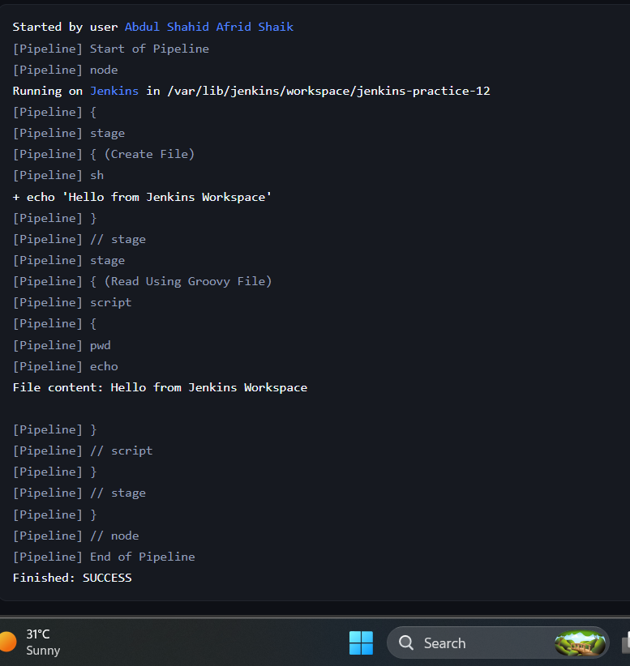

5. Reading a File Line by Line
The article demonstrates eachLine for processing a file one line at a time:
new File('example.txt').eachLine { line ->
println "Line: $line"
}
We created a workspace file containing:
Line 1: Jenkins
Line 2: Groovy
Line 3: Pipeline
The direct eachLine implementation was restricted by Jenkins Script Security.
Therefore, we are not using the restricted File.eachLine approach further.

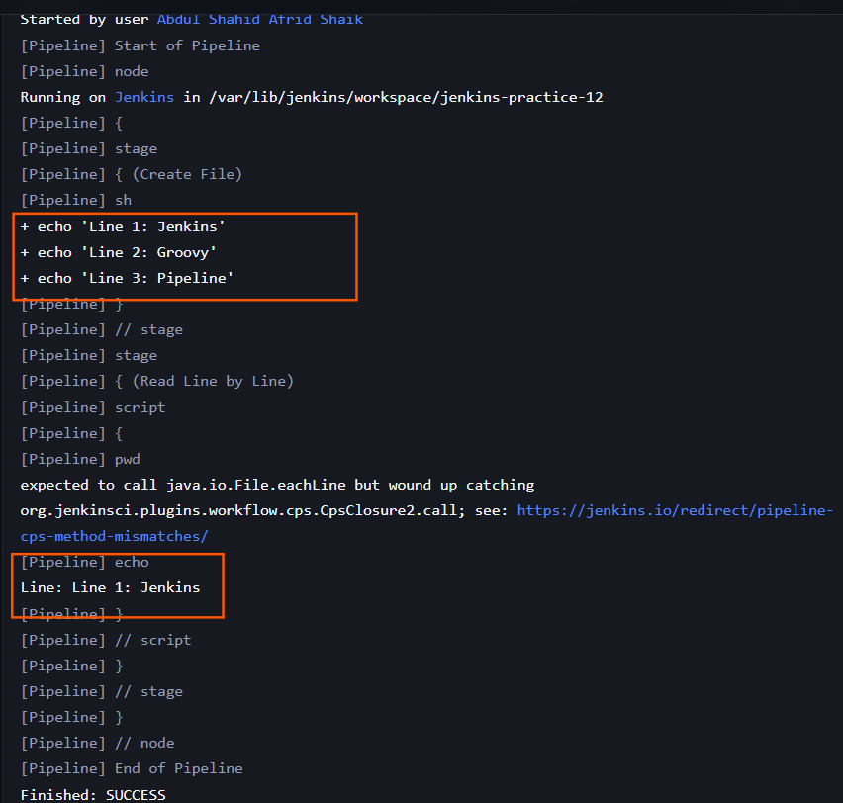

6. Reading a Specific Line
The article demonstrates reading all lines and accessing a specific line using zero-based indexing.
Article example:
def lines = new File('example.txt').readLines()
def thirdLine = lines[2]
echo "Third line: ${thirdLine}"
For Jenkins Pipeline, we are using the Jenkins-safe readFile step instead of the restricted new File() operation:
def lines = readFile('example.txt').readLines()
def thirdLine = lines[2]

echo "Third line: ${thirdLine}"
Here:
lines[0] → Line 1
lines[1] → Line 2
lines[2] → Line 3
The practical implementation is the next step we are currently testing.
Expected output
Third line: Line 3: Pipeline
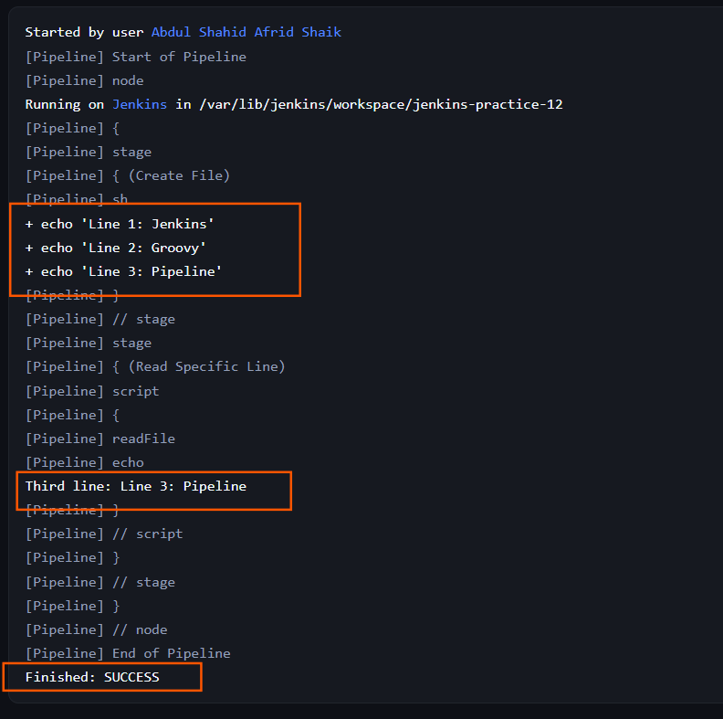

Result: Successfully read files from the Jenkins workspace using Groovy and Jenkins Pipeline methods. We created and accessed files from the workspace, used readFile() to read file content, and accessed a specific line using readLines() with zero-based indexing.

__________________________________________________________________________________________

>> How to Create Dynamic Stages in a Jenkins Pipeline

Task 3 – Dynamic Stages in a Jenkins Pipeline

1. Objective
To understand how to create and execute dynamic stages in a Jenkins Pipeline using Groovy.
The practical task was performed using a Jenkins Pipeline job named:
jenkins-practice-13

2. Concepts Covered
- Basic Jenkins Pipeline structure
- Static and Dynamic stages
- Dynamic stages using Groovy each
- Dynamic stages based on a Git branch using if/else if
- Dynamic parallel stages

3. Basic Pipeline Structure
A basic Jenkins Pipeline consists of:
- pipeline – Defines the Pipeline.
- agent – Defines where the Pipeline runs.
- stages – Contains the different stages.
- steps – Contains the commands or actions performed in a stage.
We created three basic stages:
Build → Test → Deploy
pipeline {
agent any

stages {
stage('Build') {
steps {
echo 'Building the project...'
}
}

stage('Test') {
steps {
echo 'Running tests...'
}
}

stage('Deploy') {
steps {
echo 'Deploying the application...'
}
}
}
}
The Pipeline executed successfully.

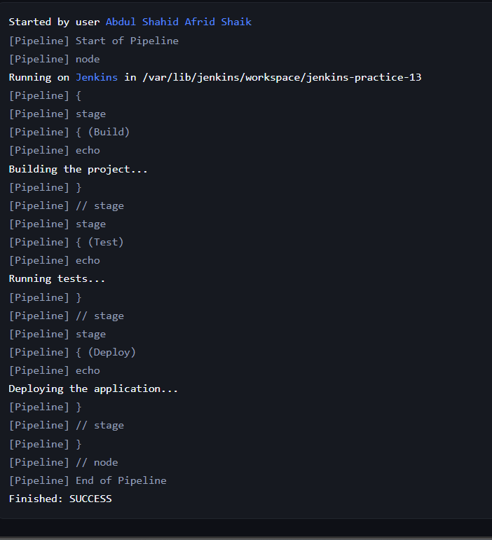

4. Dynamic Stages Using Groovy each
Dynamic stages can be created at runtime based on a list of values.
We created deployment stages for three environments:
- dev
- qa
- production
def environments = ['dev', 'qa', 'production']

pipeline {
agent any

stages {
stage('Dynamic Deployment') {
steps {
script {
environments.each { env ->
stage("Deploy to ${env}") {
echo "Deploying to ${env} environment"
}
}
}
}
}
}
}
The Pipeline dynamically created and executed:
- Deploy to dev
- Deploy to qa
- Deploy to production

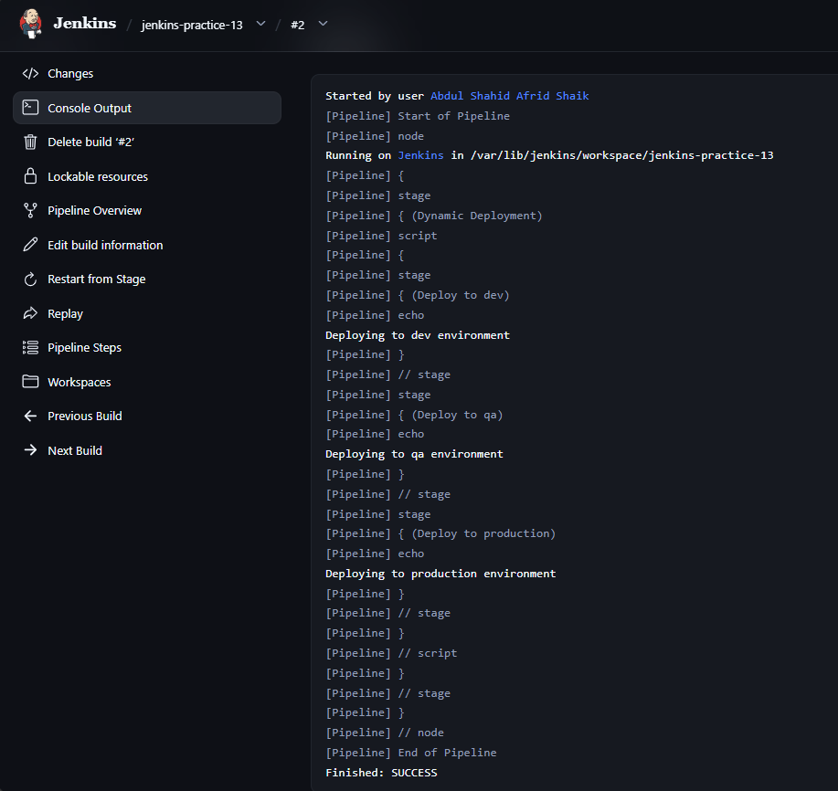

5. Dynamic Stages Based on Git Branch
Dynamic stages can also be created based on the branch being built.
For this practical, BRANCH_NAME was set to main because the Jenkins job was a normal Pipeline job and did not automatically provide a Multibranch Pipeline branch variable.
pipeline {
agent any

environment {
BRANCH_NAME = 'main'
}

stages {
stage('Determine Build Type') {
steps {
script {
if (env.BRANCH_NAME == 'main') {
stage('Production Build') {
echo 'Building for production...'
}

stage('Deploy to Production') {
echo 'Deploying to production...'
}
} else if (env.BRANCH_NAME.startsWith('feature/')) {
stage('Feature Build') {
echo 'Building feature...'
}

stage('Deploy to Dev') {
echo 'Deploying to dev...'
}
}
}
}
}
}
}
For the main branch condition, Jenkins dynamically created:
- Production Build
- Deploy to Production
The Pipeline executed successfully.

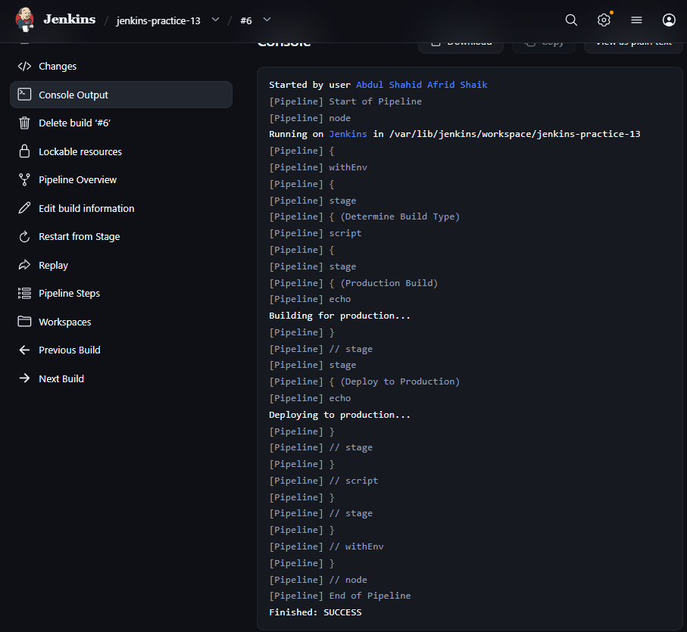

6. Dynamic Parallel Stages
Dynamic parallel stages allow multiple stages to execute simultaneously.
We created three test suites:
- Unit
- Integration
- E2E
def testSuites = ['unit', 'integration', 'e2e']

pipeline {
agent any

stages {
stage('Parallel Tests') {
steps {
script {
def parallelStages = testSuites.collectEntries {
["${it} Tests": {
echo "Executing ${it} test suite..."
}]
}

parallel parallelStages
}
}
}
}
}
Jenkins created and executed the following parallel branches:
- unit Tests
- integration Tests
- e2e Tests
All parallel branches completed successfully and the build result was SUCCESS.

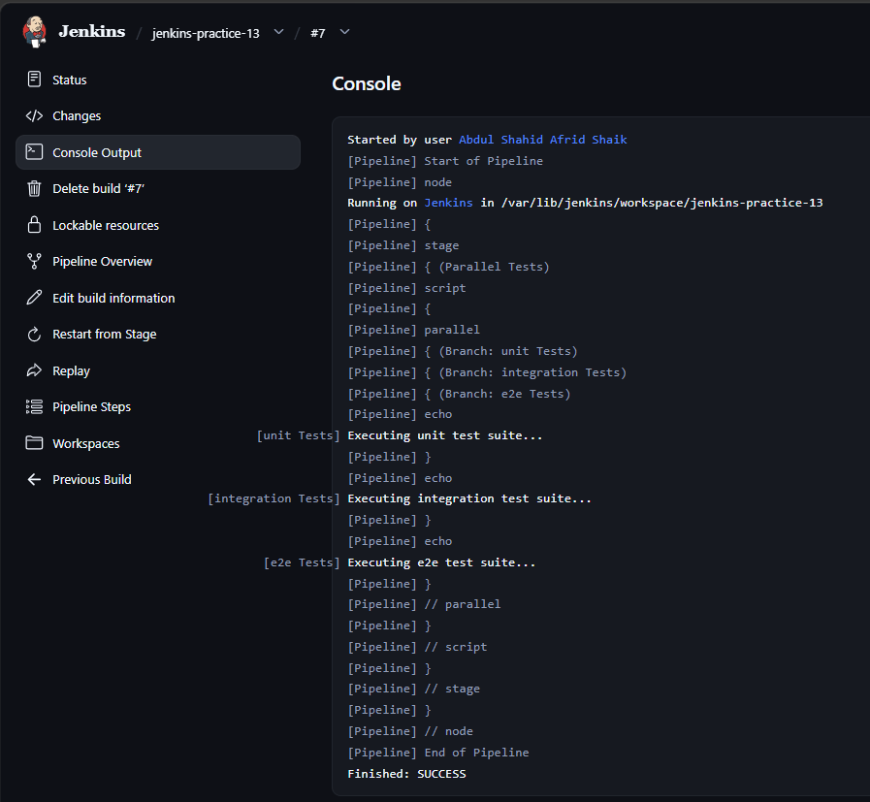

7. Result
The following dynamic stage techniques were successfully implemented:
- Basic Pipeline stages
- Dynamic stages using Groovy each
- Branch-based dynamic stages using if/else if
- Dynamic parallel stages

8. Conclusion
Dynamic stages allow Jenkins Pipelines to create stages at runtime based on conditions, lists, or other requirements.
In this task, we successfully implemented dynamic stages using Groovy each, conditional branch logic, and parallel execution.

>> Strategies for Handling Different Branches in a Jenkinsfile

Task 4 – Strategies for Handling Different Branches in a Jenkinsfile

1. Objective
To understand how Jenkins can handle different branches differently within a Jenkins Pipeline.
The practical work was performed using the Jenkins Pipeline job:
jenkins-practice-14
A separate Multibranch Pipeline job was created for the final practical:
jenkins-practice-14.1

2. Concepts Covered
- Branch-specific Pipeline execution
- when directive
- if/else branch handling
- BRANCH_NAME environment variable
- Custom environment variables
- Multibranch Pipeline

3. Task 4.1 – when Directive
The Jenkins when directive is used to execute a stage only when a specified condition is satisfied.
For this practical, we configured the branch as main and executed the production deployment stage only for the main branch.

Pipeline Used
pipeline {
agent any

environment {
BRANCH_NAME = 'main'
}

stages {
stage('Build') {
steps {
echo 'Building the application...'
}
}

stage('Deploy to Production') {
when {
expression {
env.BRANCH_NAME == 'main'
}
}
steps {
echo 'Deploying to production...'
}
}
}
}

Result
The Build stage executed successfully, followed by the Deploy to Production stage because the branch was set to main.

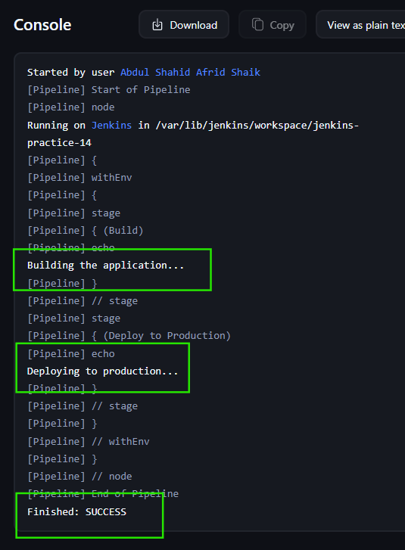

4. Task 4.2 – if/else Branch Handling
if/else statements can be used to perform different actions depending on the branch.
For this practical, different test actions were configured for main, develop, and other branches.

Pipeline Used
pipeline {
agent any

environment {
BRANCH_NAME = 'main'
}

stages {
stage('Build and Test') {
steps {
script {
if (env.BRANCH_NAME == 'main') {
echo 'Running full test suite...'
} else if (env.BRANCH_NAME == 'develop') {
echo 'Running development tests...'
} else {
echo 'Running quick tests...'
}
}
}
}
}
}

Result
Since the branch was set to main, Jenkins executed:
Running full test suite...
The Pipeline completed successfully.

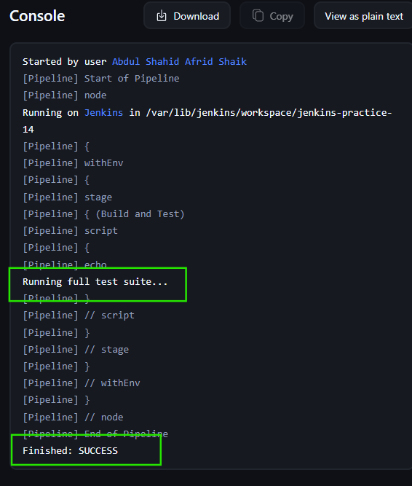

5. Task 4.3 – BRANCH_NAME Detection
BRANCH_NAME is used to identify the branch being processed.
For this practical, we used startsWith() to identify a feature branch.

Pipeline Used
pipeline {
agent any

environment {
BRANCH_NAME = 'feature/login'
}

stages {
stage('Branch Detection') {
steps {
script {
echo "Building branch: ${env.BRANCH_NAME}"

if (env.BRANCH_NAME.startsWith('feature/')) {
echo 'This is a feature branch'
} else if (env.BRANCH_NAME == 'develop') {
echo 'This is the develop branch'
} else if (env.BRANCH_NAME == 'main') {
echo 'This is the main branch'
} else {
echo 'Unknown branch'
}
}
}
}
}
}

Result
Jenkins displayed:
Building branch: feature/login
This is a feature branch
The Pipeline completed successfully.

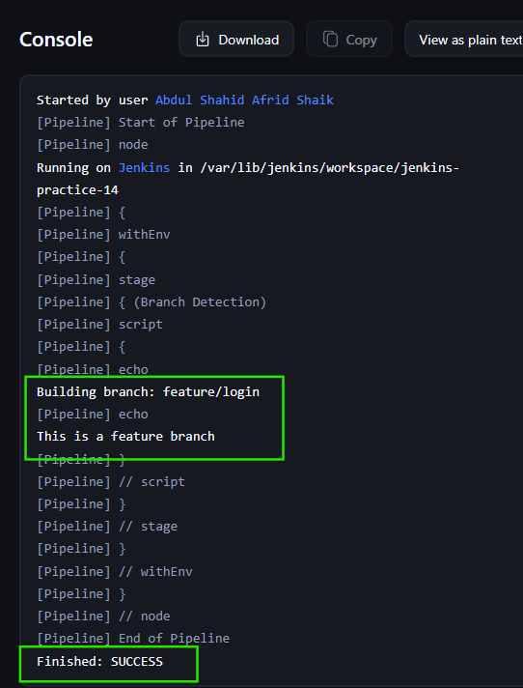

6. Task 4.4 – Custom Environment Variable
A custom environment variable DEPLOY_TARGET was created based on the branch.
For the main branch, the deployment target was set to production; otherwise, it would be staging.

Pipeline Used
pipeline {
agent any

environment {
BRANCH_NAME = 'main'
DEPLOY_TARGET = "${env.BRANCH_NAME == 'main' ? 'production' : 'staging'}"
}

stages {
stage('Deploy') {
steps {
echo "Deploying to ${env.DEPLOY_TARGET}"
}
}
}
}

Result
Since the branch was main, Jenkins displayed:
Deploying to production
The Pipeline completed successfully.

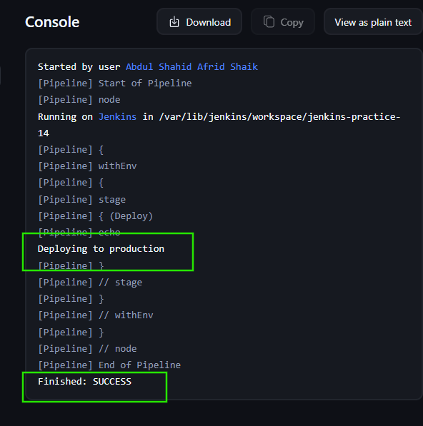

7. Task 4.5 – Multibranch Pipeline
A separate Jenkins Multibranch Pipeline job was created:
jenkins-practice-14.1

Repository Used
https://github.com/shahid8256/Git-Practice.git
The repository is public, so no GitHub credentials were required.

Configuration
The Multibranch Pipeline was configured with:
- Branch Source: GitHub
- Repository: shahid8256/Git-Practice
- Discover Branches: All branches
- Build Configuration: by Jenkinsfile
- Script Path: Jenkinsfile

Initial Repository Scan
The first scan successfully connected to GitHub and processed three branches:
- main
- feature-branch
- github-branch
However, Jenkins reported:
'Jenkinsfile' not found
Does not meet criteria
Therefore, no branch jobs were initially created.

Next Step
A simple Jenkinsfile was added to the feature-branch of the GitHub repository.
The Multibranch Pipeline was then scanned again to verify that Jenkins could discover the branch containing the Jenkinsfile.
Final scan result: Pending.
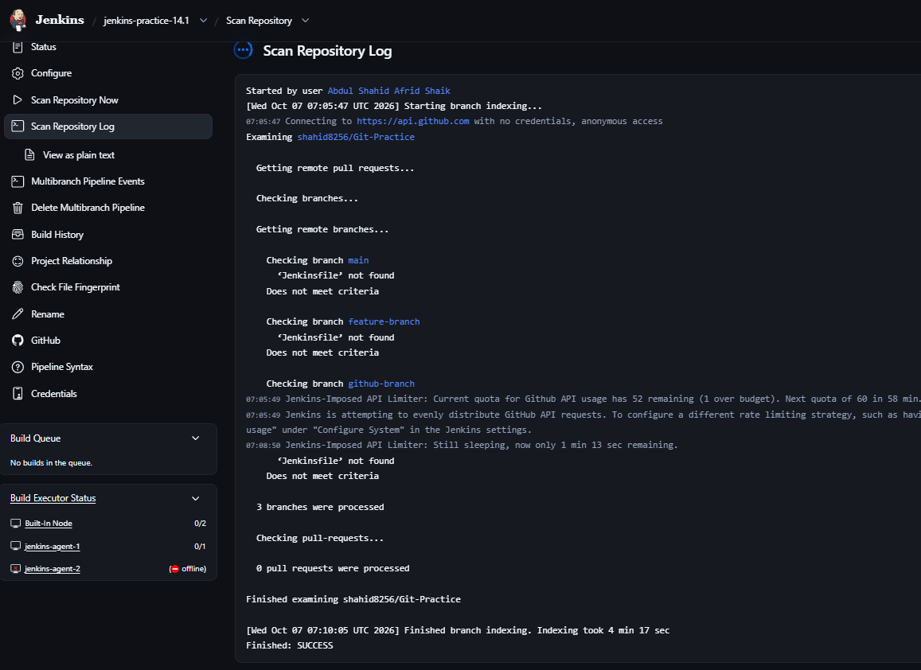

Adding Jenkinsfile to a Branch
To test branch discovery, a simple Jenkinsfile was created in the feature-branch of the GitHub repository.
The Jenkinsfile contains a basic Pipeline with:
- Build stage
- Test stage

Second Repository Scan
After adding the Jenkinsfile to feature-branch, the Multibranch Pipeline was scanned again.
Jenkins is currently checking the repository again to detect the newly added Jenkinsfile.
The expected result is that Jenkins will detect:
feature-branch
Jenkinsfile found
Meets criteria
and create a Pipeline job for the feature-branch.
Final scan result : SUCCESS

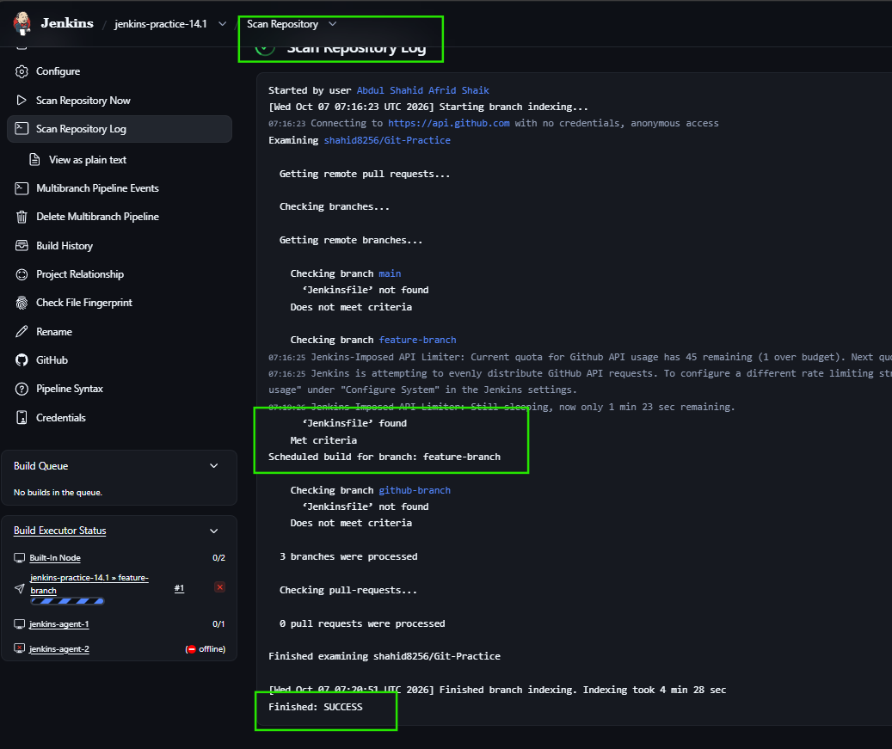

8. Result
The following branch-handling techniques were successfully implemented:
- when directive
- if/else branch handling
- BRANCH_NAME detection
- Custom environment variable
- Multibranch Pipeline configuration and repository scanning
The final Multibranch Pipeline branch-discovery result will be added after the current scan completes.

9. Conclusion
This task demonstrated how Jenkins Pipelines can behave differently depending on the branch being processed.
We implemented conditional execution using when, if/else logic, branch detection using BRANCH_NAME, custom deployment targets, and configured a Multibranch Pipeline to automatically discover branches containing a Jenkinsfile.

___________________________________________________________________________

>> Getting a JSON Object as a Parameter in a Jenkins Pipeline

Task 5 – Getting a JSON Object as a Parameter in a Jenkins Pipeline

1. Objective
To understand how to pass JSON data as a Jenkins Pipeline parameter and parse the JSON data inside the Pipeline.
The practical work was performed using the Jenkins Pipeline job:
jenkins-practice-15

2. Concepts Covered
- Creating a JSON parameter using a Multi line parameter
- Printing JSON parameter data
- Parsing JSON using readJSON
- Parsing JSON using Groovy JsonSlurper

3. Task 5.1 – Create JSON Text Parameter
Jenkins does not provide a specific JSON parameter type. A Multi line parameter can be used to enter JSON data.

Parameter Configuration
Parameter Type:
Multi line
Parameter Name:
student

JSON Value Used
{
"name": "AFRID",
"grade": "A",
"subjects": [
{
"name": "Math",
"passed": true
},
{
"name": "Science",
"passed": true
}
]
}

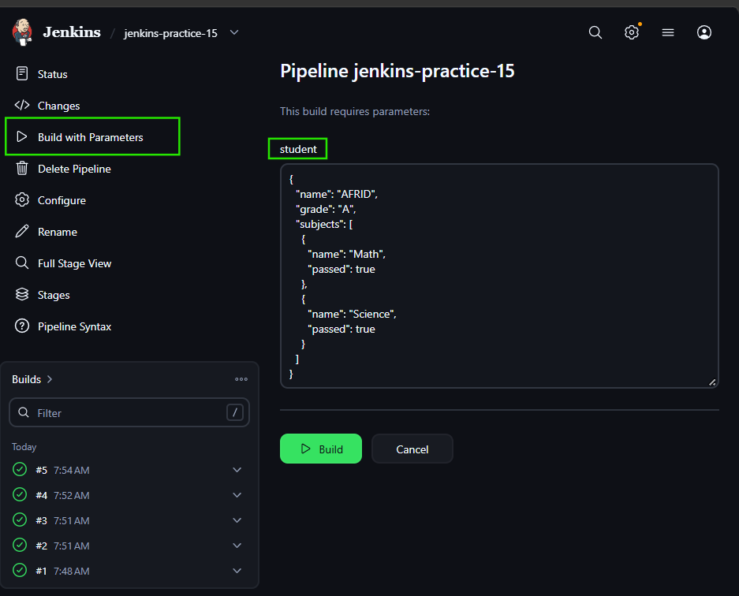

Pipeline Used
pipeline {
agent any

stages {
stage('Print JSON Parameter') {
steps {
echo student
}
}
}
}

Execution
We used Build with Parameters and provided the JSON parameter.

Result
The complete JSON data was successfully displayed in the Jenkins Console Output.
The build completed with:
Finished: SUCCESS

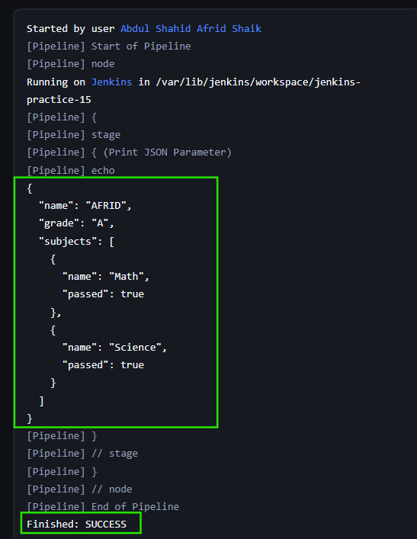

4. Task 5.2 – Parse JSON Using readJSON
The readJSON step was used to convert the JSON text parameter into an object and access individual JSON properties.

Pipeline Used
pipeline {
agent any

stages {
stage('Parse JSON Parameter') {
steps {
script {
def myobj = readJSON text: student

echo "The student name is ${myobj.name}"
echo "The grade is ${myobj.grade}"
echo "The subjects are ${myobj.subjects[0].name} and ${myobj.subjects[1].name}"
}
}
}
}
}

Result
The Pipeline successfully parsed the JSON and displayed:
The student name is AFRID
The grade is A
The subjects are Math and Science
The build completed successfully.

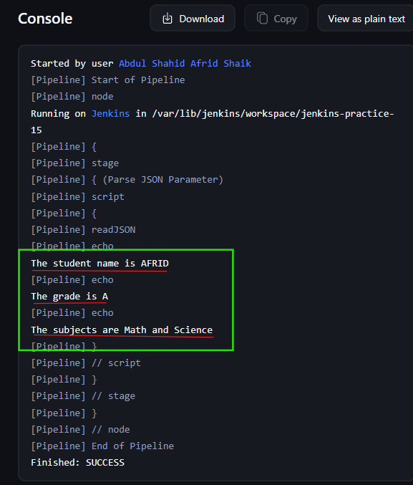

5. Task 5.3 – Parse JSON Using Groovy JsonSlurper
The JSON parameter was also parsed using the Groovy JsonSlurper class.

Pipeline Used
import groovy.json.JsonSlurper

pipeline {
agent any

stages {
stage('Parse JSON Using JsonSlurper') {
steps {
script {
def myobj = new JsonSlurper().parseText(student)

echo "The student grade is ${myobj.grade}"

for (int i = 0; i < myobj.subjects.size(); i++) {
if (myobj.subjects[i].passed) {
echo "He passed the ${myobj.subjects[i].name}"
} else {
echo "He failed the ${myobj.subjects[i].name}"
}
}
}
}
}
}
}

Result
The Pipeline successfully parsed the JSON and displayed:
The student grade is A
He passed the Math
He passed the Science
The build completed successfully.

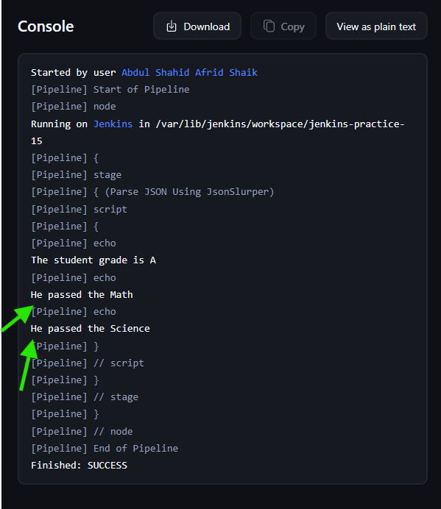

6. Difference Between readJSON and JsonSlurper
Both methods were successfully used to parse the same JSON parameter.

readJSON
- Jenkins Pipeline Utility step.
- Provides a simple way to parse JSON in a Jenkins Pipeline.
- Used to access JSON properties directly.

JsonSlurper
- Standard Groovy class.
- Used to parse JSON text into a Groovy object.
- Provides more programming flexibility for processing JSON data.

7. Result
The following JSON operations were successfully implemented:
- Created a Multi line Jenkins parameter containing JSON.
- Printed the JSON parameter in the Pipeline.
- Parsed the JSON using readJSON.
- Parsed the JSON using Groovy JsonSlurper.
- Accessed JSON properties and processed subject information.
All implemented Pipeline builds completed successfully.

8. Conclusion
This task demonstrated how JSON data can be passed to a Jenkins Pipeline as a Multi line parameter and processed inside the Pipeline.
The JSON parameter was successfully parsed using both readJSON and Groovy JsonSlurper, allowing individual JSON values to be accessed and used in the Pipeline.

___________________________________________________________________________

>> How to Check if a Pipeline Parameter Is Empty in Jenkins

Task 6 – How to Check if a Pipeline Parameter Is Empty in Jenkins

1. Objective
To understand how to define a Jenkins Pipeline parameter and check whether the parameter contains a value or is empty.
The practical work was performed using the Jenkins Pipeline job:
jenkins-practice-16

2. Concepts Covered
- Jenkins Pipeline parameters
- String parameter
- Printing parameter values
- Checking an empty parameter using isEmpty()
- Checking an empty parameter using if/else
- Handling both empty and non-empty parameter values

3. Task 6.1 – Define and Print a Jenkins Parameter
A String parameter named environment was created using the Jenkins job configuration.

Parameter Configuration
Parameter Type:
String Parameter
Parameter Name:
environment
Description:
This is the target environment for deployment

Pipeline Used
pipeline {
agent any

stages {
stage('Print Parameter Value') {
steps {
echo "We'll deploy on the ${environment} environment"
}
}
}
}

Execution
The Pipeline was triggered using Build with Parameters.
The parameter value was provided as:
production

Result
The Jenkins console displayed:
We'll deploy on the production environment
The build completed successfully.
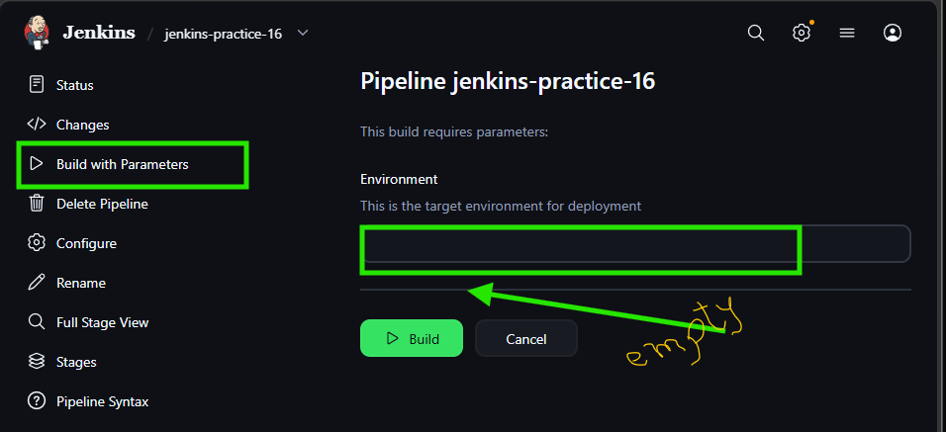
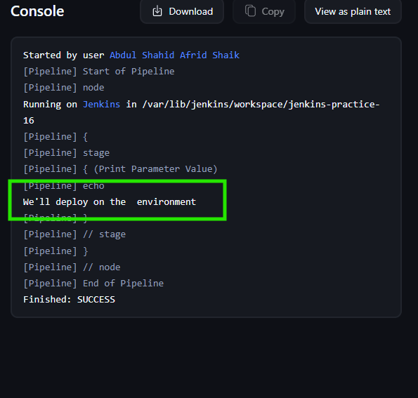

4. Task 6.2 – Check Empty Parameter Using isEmpty()
The isEmpty() function was used to check whether the environment parameter contains an empty string.
The if/else logic was placed inside a script block.

Pipeline Used
pipeline {
agent any

stages {
stage('Check Parameter') {
steps {
script {
if (environment.isEmpty()) {
echo "The environment parameter cannot be empty"
} else {
echo "We'll deploy on the ${environment} environment"
}
}
}
}
}
}

Execution
The environment parameter was intentionally left empty during the test.

Result
Jenkins detected the empty parameter and displayed:
The environment parameter cannot be empty
This confirmed that isEmpty() can be used to check whether a parameter contains a value.

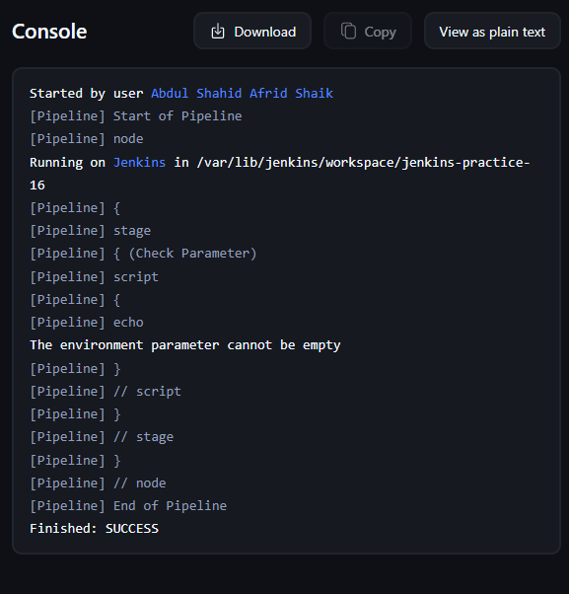

5. Task 6.3 – Check Empty Parameter Using if/else
The second approach was to directly compare the parameter with an empty string or null.

Pipeline Used
pipeline {
agent any

stages {
stage('Check Parameter') {
steps {
script {
if (environment == '' || environment == null) {
echo "The environment parameter is again empty"
} else {
echo "We'll deploy on the ${environment} environment"
}
}
}
}
}
}

Empty Parameter Test
The parameter was left empty.
Jenkins displayed:
The environment parameter is again empty

Non-Empty Parameter Test
The parameter was then provided with:
production
Jenkins displayed:
We'll deploy on the production environment
Both empty and non-empty cases worked successfully.

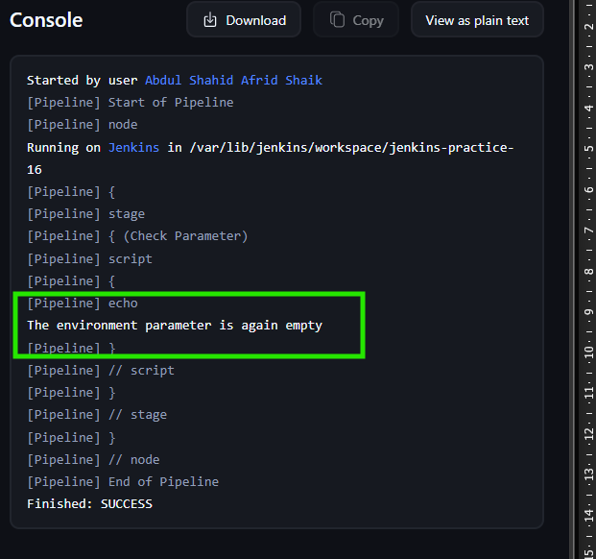

6. Purpose of the Parameter Testing
The parameter was used only to demonstrate how Jenkins can detect and handle an empty value.
No actual deployment was performed using the environment parameter.
The main purpose of the task was to validate the parameter and apply appropriate logic when the value is empty or non-empty.

7. Difference Between the Two Empty Checks

isEmpty()
environment.isEmpty()
Checks whether the parameter contains an empty string.

if/else Comparison
environment == '' || environment == null
Directly checks whether the parameter is empty or null.
Both approaches were successfully tested.

8. Result
The following tasks were successfully completed:
- Created and printed a Jenkins String parameter.
- Checked an empty parameter using isEmpty().
- Checked an empty parameter using if/else.
- Tested both empty and non-empty parameter values.
All practical Pipeline executions completed successfully.

9. Conclusion
Jenkins Pipeline parameters can be used to provide input to a Pipeline and control its behavior.
Checking whether a parameter is empty helps prevent unexpected Pipeline behavior and allows the Pipeline to handle missing input appropriately.
In this task, both isEmpty() and if/else approaches were successfully implemented and tested.

__________________________________________________________________________

>> Jenkins Walkthrough and Scripting Filesystem Operations

Yes. The previous notes had the concepts and code, but they were missing the important practical steps. Here is the improved Task 7 version you can add to Word.

Task 7 — Jenkins Walkthrough and Filesystem Operations

7.1 — Jenkins Basic Terminology

Important Terms
Job: A task configured in Jenkins.
Pipeline: Defines the sequence of activities Jenkins should execute.
Stage: A major phase of a Pipeline such as Build, Test, or Deploy.
Step: An individual action performed inside a stage.
Agent: The machine where Jenkins executes the Pipeline.
Executor: A slot on an agent that runs a build.
Build: One execution of a Jenkins job.

Practical Steps
Step 1: Open Jenkins.
Step 2: Open the existing job:
jenkins-practice-17
Step 3: Click Configure.
Step 4: Go to Pipeline → Script.
Step 5: Enter:
pipeline {
agent any

stages {
stage('Build') {
steps {
echo 'This is a Build stage'
}
}

stage('Test') {
steps {
echo 'This is a Test stage'
}
}
}
}
Step 6: Click Save.
Step 7: Click Build Now.
Step 8: Open the build → Console Output.
Result:
This is a Build stage
This is a Test stage
Finished: SUCCESS

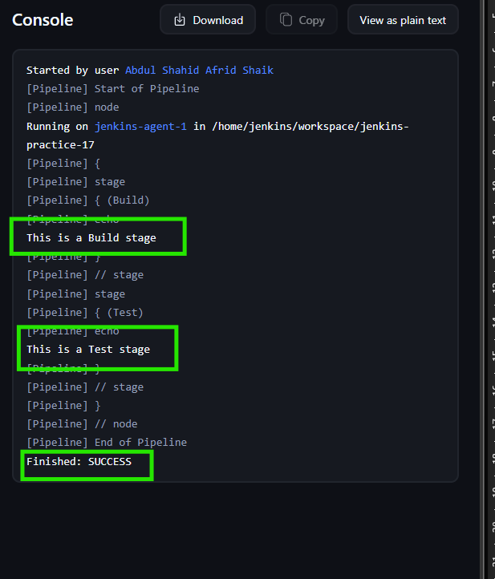

7.2 — Check Jenkins Environment and Workspace

Important Points
JENKINS_HOME is the main Jenkins data directory.
The Pipeline workspace is the directory where the job's files are created and processed.

Practical Steps
Step 1: Open:
jenkins-practice-17 → Configure → Pipeline
Step 2: Use:
pipeline {
agent any

stages {
stage('Check Jenkins Environment') {
steps {
sh '''
echo "User: $(whoami)"
echo "Home: $HOME"
echo "Workspace: $WORKSPACE"
echo "JENKINS_HOME: ${JENKINS_HOME:-Not Set}"

echo "Workspace contents:"
ls -la "$WORKSPACE"
'''
}
}
}
}
Step 3: Click Save.
Step 4: Click Build Now.
Step 5: Open Console Output.

Our Jenkins Agent Output
User: jenkins
Home: /home/jenkins
Workspace: /home/jenkins/workspace/jenkins-practice-17
JENKINS_HOME: /var/lib/jenkins
Important: /var/lib/jenkins was not present on our agent, so we did not create or modify it.

Result
The build completed successfully and we identified:
Jenkins User → jenkins
Home → /home/jenkins
Workspace → /home/jenkins/workspace/jenkins-practice-17
JENKINS_HOME → /var/lib/Jenkins

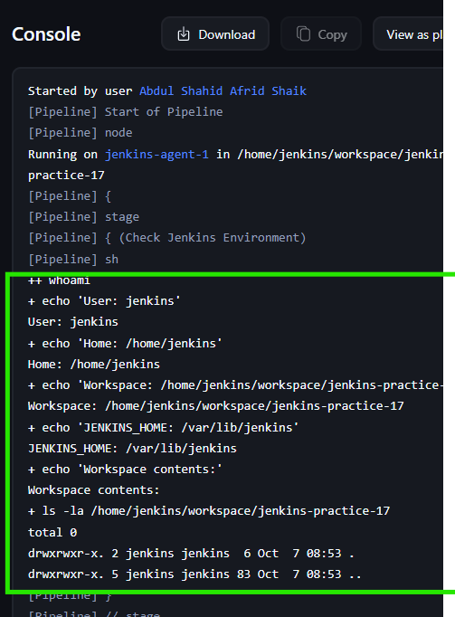

7.3 — Jenkins Console Output / Build Logs

Purpose
Console Output shows the commands and messages generated during a Jenkins build.

Practical Steps
Step 1: Open the Pipeline configuration.
Step 2: Enter:
pipeline {
agent any

stages {
stage('Generate Logs') {
steps {
echo 'Starting the build...'
echo 'Running some Jenkins steps...'
sh 'echo "This message comes from the shell"'
echo 'Build completed successfully.'
}
}
}
}
Step 3: Click Save.
Step 4: Click Build Now.
Step 5: Open the build number.
Step 6: Click Console Output.

Expected Output
Starting the build...
Running some Jenkins steps...
This message comes from the shell
Build completed successfully.
Finished: SUCCESS

Important Jenkins Navigation
Jenkins
→ Job
→ Build Number
→ Console Output

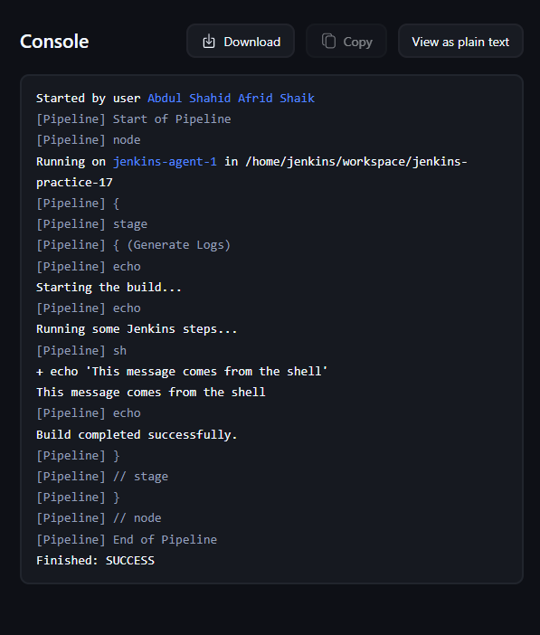

7.4 — Copy Files Using Shell sh

Purpose
Copy a file using the Linux cp command through the Jenkins sh step.

Practical Steps
Step 1: Open:
jenkins-practice-17 → Configure → Pipeline
Step 2: Enter:
pipeline {
agent any

stages {
stage('Create Source File') {
steps {
sh 'echo "Hello from Jenkins" > source.txt'
}
}

stage('Copy File') {
steps {
sh 'cp source.txt copied.txt'
sh 'ls -l source.txt copied.txt'
}
}

stage('Verify File') {
steps {
sh 'cat copied.txt'
}
}
}
}
Step 3: Click Save.
Step 4: Click Build Now.
Step 5: Open Console Output.

File Flow
source.txt
↓
cp source.txt copied.txt
↓
copied.txt

Verification
The ls command confirms both files exist, and cat displays the copied file's contents.

Important Point
We used the Jenkins workspace instead of /var/source and /var/destination to avoid unnecessary permission problems.
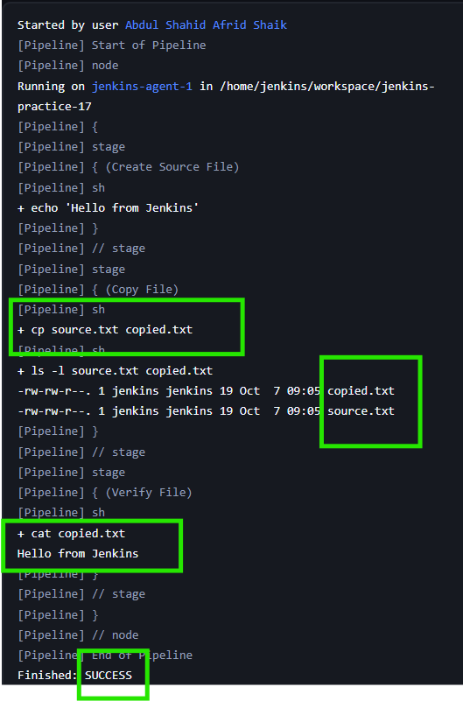

7.5 — Copy File Using Groovy/Jenkins File Steps

Important Point
The article demonstrates native filesystem operations using Groovy/Java APIs. In our Jenkins Pipeline, direct operations such as:
destination.bytes = source.bytes
were blocked by Jenkins Script Security.
Therefore, we used Jenkins-supported file steps instead of approving a filesystem API signature unnecessarily.

Practical Steps
Step 1: Open Pipeline configuration.
Step 2: Enter:
pipeline {
agent any

stages {
stage('Create Source File') {
steps {
writeFile file: 'source.txt', text: 'Hello from Groovy'
}
}

stage('Copy File Using Groovy') {
steps {
script {
def source = readFile('source.txt')
writeFile file: 'copied.txt', text: source
echo 'File copied successfully using Groovy'
}
}
}

stage('Verify File') {
steps {
echo readFile('copied.txt')
}
}
}
}
Step 3: Click Save.
Step 4: Click Build Now.
Step 5: Open Console Output.

File Flow
source.txt
↓
readFile()
↓
Groovy variable
↓
writeFile()
↓
copied.txt

Result
The file was successfully read, written to a new file, and verified.
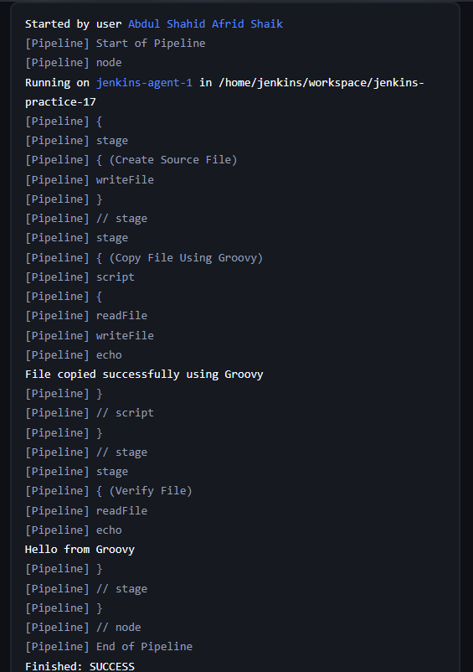

7.6 — Copy File Using File Operations Plugin

Requirement
The File Operations Plugin must be installed.
We verified that the plugin was already installed in our Jenkins.

Practical Steps
Step 1: Open:
jenkins-practice-17 → Configure → Pipeline
Step 2: Enter:
pipeline {
agent any

stages {
stage('Create Source File') {
steps {
writeFile file: 'source.txt',
text: 'Hello from File Operations Plugin'
}
}

stage('Copy File') {
steps {
fileOperations([
fileCopyOperation(
includes: 'source.txt',
targetLocation: 'backup'
)
])
}
}

stage('Verify Copy') {
steps {
sh 'ls -l backup/'
sh 'cat backup/source.txt'
}
}
}
}
Step 3: Click Save.
Step 4: Click Build Now.
Step 5: Open Console Output.

Expected File Structure
workspace/
├── source.txt
└── backup/
└── source.txt

Verification
ls -l backup/
confirms the copied file exists.
cat backup/source.txt
displays:
Hello from File Operations Plugin

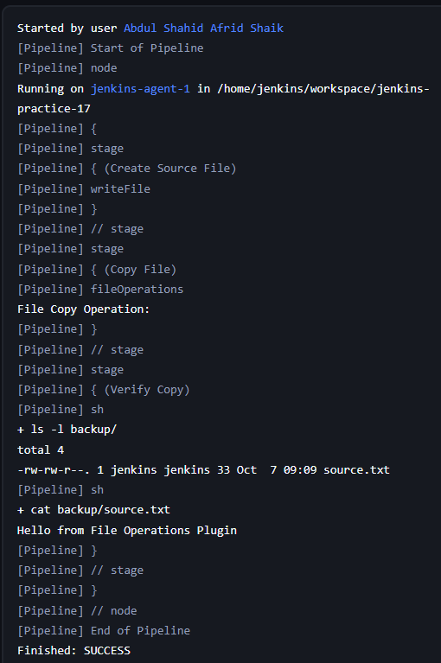

Task 7 — Important Commands Used
Command / Step | Purpose
whoami | Shows the current user
echo $HOME | Shows the user's home directory
echo $WORKSPACE | Shows Jenkins workspace
echo $JENKINS_HOME | Shows Jenkins home environment variable
ls -la | Lists files and directories
cp | Copies files
cat | Displays file contents
sh | Executes shell commands
readFile() | Reads a workspace file
writeFile() | Creates/writes a workspace file
fileCopyOperation() | Copies files using File Operations Plugin

Final Result
7.1 Jenkins Terminology ✅
7.2 Jenkins Environment/Workspace ✅
7.3 Console Output / Build Logs ✅
7.4 File Copy using sh/cp ✅
7.5 File Copy using Groovy steps ✅
7.6 File Operations Plugin ✅
Task 7 completed successfully.

_____________________________________________________________

>> Jenkins Pipeline – Git Checkout With Credentials

Task 8 — Jenkins Pipeline: Git Checkout With Credentials

Objective
The objective of this task is to understand how Jenkins securely checks out code from a GitHub repository using Jenkins-managed credentials.
We practiced both:
- HTTPS + GitHub Personal Access Token (PAT)
- SSH + Private Key
We also configured SSH host-key verification.

8.1 — Create Jenkins Git Credentials
Jenkins allows credentials to be stored securely and referenced from a Pipeline using a credentialsId.
We first created a Username with Password credential for GitHub. The password field contains the GitHub Personal Access Token (PAT).

Step 1 — Open Jenkins Credentials
Go to:
Jenkins Dashboard → Manage Jenkins → Credentials
Then:
Stores scoped to Jenkins → System → Global credentials (unrestricted)
Click:
Add Credentials

Step 2 — Configure Username + Password Credential
Select:
Kind: Username with password
Scope: Global
Enter:
Username: GitHub username
Password: GitHub Personal Access Token
ID: github-pat
Description: GitHub PAT for Jenkins Git checkout
Leave:
Treat username as secret: Unchecked
Click Create.

Important
The GitHub PAT should not be written directly inside the Jenkinsfile.
The Pipeline only references:
credentialsId: 'github-pat'

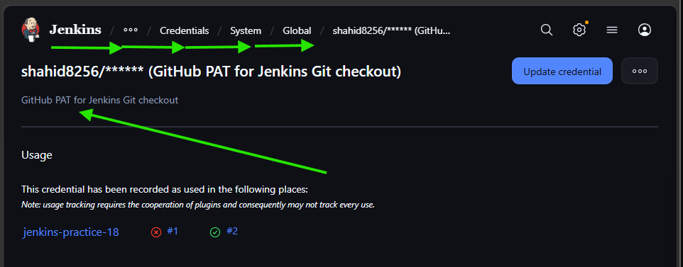

8.2 — Git Checkout Using Username + PAT
We used the Jenkins credential to checkout the GitHub repository through HTTPS.
Repository:
https://github.com/shahid8256/Git-Practice.git
Branch:
main

Step 1 — Configure Pipeline
Open:
Jenkins → jenkins-practice-18 → Configure → Pipeline → Script
Use:
pipeline {
agent any

stages {
stage('Git Checkout') {
steps {
git branch: 'main',
credentialsId: 'github-pat',
url: 'https://github.com/shahid8256/Git-Practice.git'
}
}

stage('Verify Checkout') {
steps {
sh 'git branch --show-current'
sh 'git log -1 --oneline'
sh 'ls -la'
}
}
}
}

Step 2 — Initial Build Error
The first build failed with:
Cannot run program "git"
Exec failed, error: 2 (No such file or directory)
The important part was:
using credential github-pat
So Jenkins had successfully found the credential.

Reason
Git was not installed on the Jenkins agent where the Pipeline was executing.
The Pipeline was running on:
jenkins-agent-1

Step 3 — Check Git on the Agent
SSH into the Jenkins agent and run:
git --version
Initially:
git: command not found

Step 4 — Install Git
On the Amazon Linux Jenkins agent:
sudo dnf install git -y
Then verify:
git --version
Output:
git version 2.50.1
Because Jenkins executes the checkout as the jenkins user, we also verified:
sudo -u jenkins git --version
Output:
git version 2.50.1

Step 5 — Run the Pipeline Again
The checkout then succeeded.
Jenkins showed:
using credential github-pat
Git fetched the repository:
git fetch --tags --force --progress
The main branch was checked out.
Verification showed:
main
The workspace contained files such as:
README.md
anotherfile.txt
branchfile.txt
githubfile.txt
sample.txt
Final result:
Finished: SUCCESS

Important Learning
Before using Git checkout in a Pipeline, make sure Git is installed and accessible to the Jenkins user on the agent where the Pipeline runs.

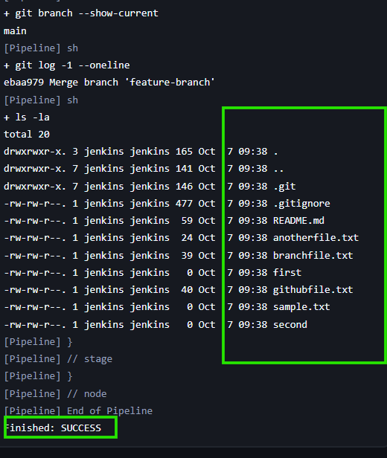

8.3 — Create SSH Git Credential
The article also demonstrates Git checkout using SSH credentials.
For SSH authentication, we need:
Private Key → Jenkins
Public Key → GitHub
We first checked the existing SSH configuration on our actual Jenkins agent.

Step 1 — Check Existing SSH Keys
On jenkins-agent-1:
ls -la ~/.ssh
We found:
authorized_keys
There was no GitHub SSH key.
We also checked:
ls -la ~/.ssh/id_*
Result:
No such file or directory

Important
The existing:
authorized_keys
is used for SSH access to the EC2 instance.
It is not the GitHub SSH key we need for this practical.

Step 2 — Create SSH Directory for Jenkins
Because Jenkins performs the Git checkout as the jenkins user:
sudo -u jenkins mkdir -p /home/jenkins/.ssh

Step 3 — Generate SSH Key
Run:
sudo -u jenkins ssh-keygen -t ed25519 -C "jenkins-github"
When asked for the file location, press Enter to use the default:
/home/jenkins/.ssh/id_ed25519
For the passphrase, press Enter twice for this lab.
This created:
/home/jenkins/.ssh/id_ed25519
/home/jenkins/.ssh/id_ed25519.pub

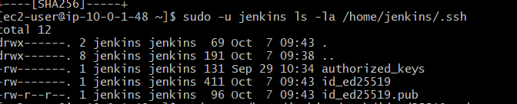

Step 4 — Add Public Key to GitHub
Display the public key:
sudo cat /home/jenkins/.ssh/id_ed25519.pub
Copy the complete public key.
In GitHub:
Profile → Settings → SSH and GPG keys → New SSH key
Enter:
Title: Jenkins Agent
Key type: Authentication Key
Paste the public key.
Click:
Add SSH key

Important
Only the .pub key is added to GitHub.
The private key:
id_ed25519
must remain private.
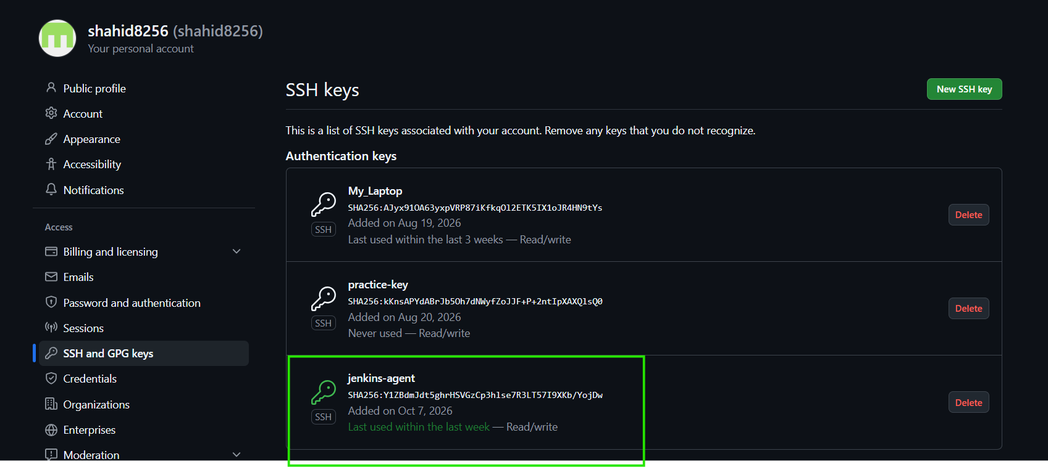

Step 5 — Create Jenkins SSH Credential
Go to:
Jenkins → Manage Jenkins → Credentials → System → Global credentials (unrestricted) → Add Credentials
Select:
Kind: SSH Username with private key
Scope: Global
Username: jenkins
Select:
Private Key → Enter directly
Get the private key from the agent:
sudo cat /home/jenkins/.ssh/id_ed25519
Copy the complete private key into Jenkins.
Leave:
Passphrase: Empty
Configure:
ID: github-ssh
Description: GitHub SSH for Jenkins checkout
Click Create.

Important
We now have two different SSH credentials:
agent-1-ssh
This is used for:
Jenkins Controller → Jenkins Agent
And:
github-ssh
This is used for:
Jenkins Agent → GitHub
They should not be confused.

8.4 — Git Checkout Using SSH Credential
Now we used the newly created github-ssh credential to checkout the repository.

Step 1 — Update Pipeline
Go to:
jenkins-practice-18 → Configure → Pipeline → Script
Use:
pipeline {
agent any

stages {
stage('Git Checkout Using SSH') {
steps {
git branch: 'main',
credentialsId: 'github-ssh',
url: 'git@github.com:shahid8256/Git-Practice.git'
}
}

stage('Verify Checkout') {
steps {
sh 'git branch --show-current'
sh 'git log -1 --oneline'
sh 'ls -la'
}
}
}
}

Step 2 — Run the Pipeline
The first SSH checkout failed.
The important error was:
No ED25519 host key is known for github.com
Host key verification failed.
Jenkins also displayed:
known_hosts file does not exist

Reason
Jenkins was using the:
Known hosts file
verification strategy.
However, the required GitHub host key was not available in the configured known_hosts file.
The SSH credential itself was working because Jenkins showed:
using credential github-ssh
Therefore, we did not recreate the SSH credential.
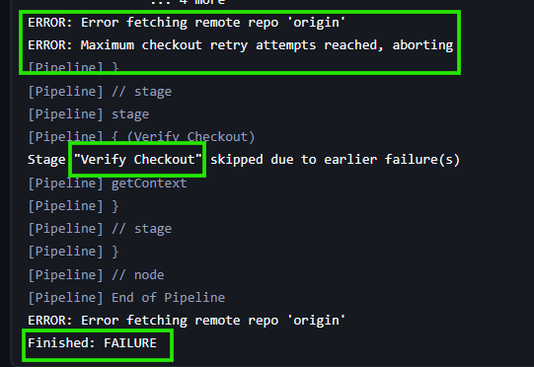

8.5 — Configure SSH Host Key Verification

Step 1 — Open Git Host Key Verification
Go to:
Manage Jenkins → Security
Find:
Git Host Key Verification Configuration

Step 2 — Change Verification Strategy
The existing strategy was:
Known hosts file

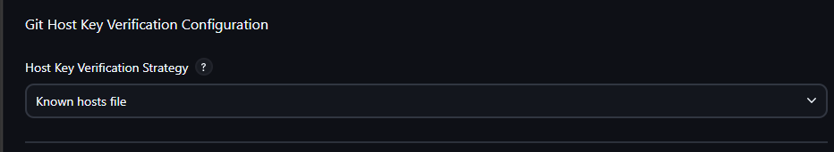

For this practical, we changed it to:
Accept first connection
Click:
Save
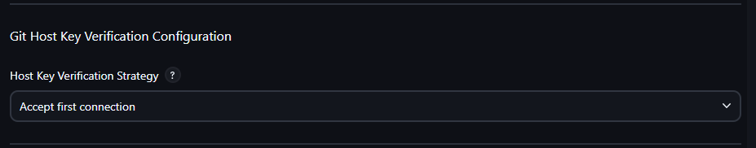

Step 3 — Run the SSH Pipeline Again
We did not change the Jenkinsfile.
Run:
jenkins-practice-18 → Build Now

Successful Result
Jenkins showed:
using credential github-ssh
Then:
Verifying host key using known hosts file,
will automatically accept unseen keys
Git successfully fetched the repository.
The main branch was checked out:
main
The latest commit was:
ebaa979 Merge branch 'feature-branch'
The repository files were present in the workspace.
Final result:
Finished: SUCCESS

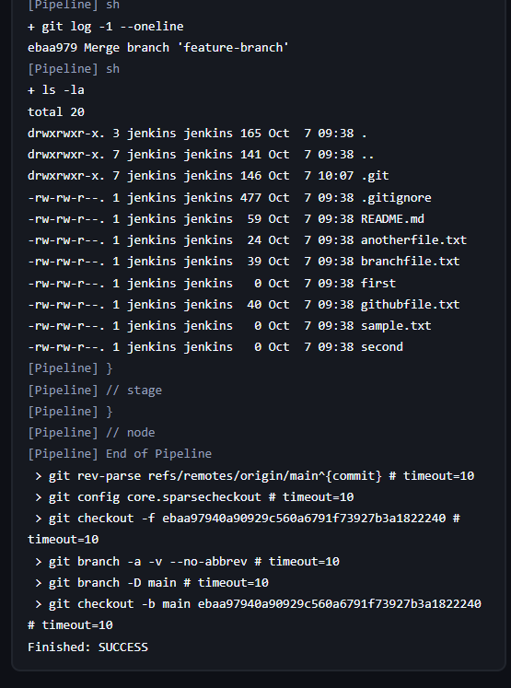

Important Git Checkout Pipeline Syntax

HTTPS + GitHub PAT
git branch: 'main',
credentialsId: 'github-pat',
url: 'https://github.com/shahid8256/Git-Practice.git'

SSH + Private Key
git branch: 'main',
credentialsId: 'github-ssh',
url: 'git@github.com:shahid8256/Git-Practice.git'

Important Commands Used

Check Git
git --version

Check Git as Jenkins user
sudo -u jenkins git --version

Check SSH directory
ls -la ~/.ssh

Generate SSH key
sudo -u jenkins ssh-keygen -t ed25519 -C "jenkins-github"

Display public key
sudo cat /home/jenkins/.ssh/id_ed25519.pub

Display private key
sudo cat /home/jenkins/.ssh/id_ed25519
Never share the private key publicly.

PAT vs SSH
Both methods work for Jenkins Git checkout.
Method | Jenkins Credential | Repository URL
HTTPS + PAT | github-pat | https://github.com/...
SSH | github-ssh | git@github.com:...
For our actual Jenkins setup, HTTPS + GitHub PAT is simpler because it doesn't require SSH host-key configuration.
The SSH method was practiced because the Baeldung article specifically covers SSH credentials and host-key verification.

Task 8 — Final Result
8.1 Create Username + PAT Credential ✅
8.2 Git Checkout Using PAT ✅
└─ Git missing on agent → installed Git
8.3 Create SSH Git Credential ✅
8.4 Git Checkout Using SSH ✅
└─ Host key verification failed initially
8.5 Configure SSH Host Key Verification ✅
└─ Changed to Accept first connection
Task 8 completed successfully. ✅

_________________________________________________________________

>> How to Use Conditional Constructs in Jenkins Pipeline

Task 9 — How to Use Conditional Constructs in Jenkins Pipeline

Objective
In this task, we learned how to control the execution flow of a Jenkins Pipeline using different conditional constructs.
The main concepts covered were:
- Shell test command
- if-else inside sh
- Groovy if-else
- Groovy ternary operator
- Scripted Pipeline
- when directive
The article explains that conditional constructs allow Jenkins Pipelines to change their execution flow based on variables and other conditions. Pasted text

Task 9.1 — sh With test Command

What we are learning
In this practical, we learned how to use the Linux test command inside a Jenkins sh step to conditionally execute a command.
The test -z command checks whether a variable is empty.
The article uses the SKIP_BUILD environment variable for this example. Pasted text

Jenkins Job
Job name:
jenkins-practice-19
Job type:
Pipeline

Pipeline Script
pipeline {
agent any

stages {
stage('Build') {
steps {
sh '''
test -z "$SKIP_BUILD" && echo "Starting the build..."
'''
}
}
}
}

Understanding the Script
This command:
test -z "$SKIP_BUILD"
checks whether SKIP_BUILD is empty.
The && means:
Execute the next command only if the previous command succeeds.
Therefore:
test -z "$SKIP_BUILD" && echo "Starting the build..."
means:
If SKIP_BUILD is empty, print "Starting the build..."
Since we did not define SKIP_BUILD, the condition was true.

Expected Output
Starting the build...
Finished: SUCCESS

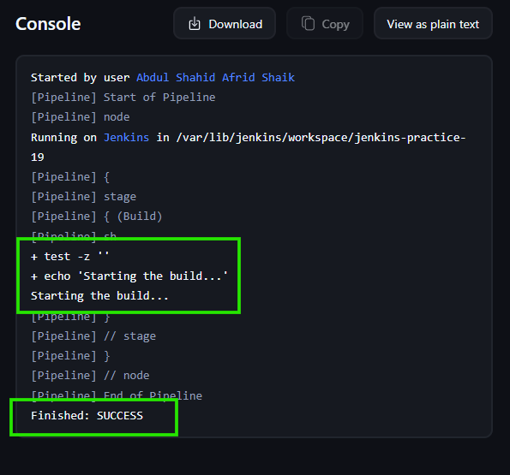

Task 9.2 — if-else Inside sh

What we are learning
In this practical, we learned how to use a complete shell if-else condition inside the Jenkins sh step.
Instead of using:
test -z "$SKIP_BUILD" && ...
we use:
if
then
else
fi
The article demonstrates this approach in section 2.2. Pasted text

Pipeline Script
pipeline {
agent any

stages {
stage('Build') {
steps {
script {
sh '''
if [ -z "$SKIP_BUILD" ]
then
echo "Starting the build..."
else
echo "Skipping the build..."
fi
'''
}
}
}
}
}

Understanding the Script
This condition:
if [ -z "$SKIP_BUILD" ]
checks whether SKIP_BUILD is empty.
If it is empty:
echo "Starting the build..."
is executed.
Otherwise:
echo "Skipping the build..."
is executed.

Expected Output
Because SKIP_BUILD was not defined:
Starting the build...
Finished: SUCCESS

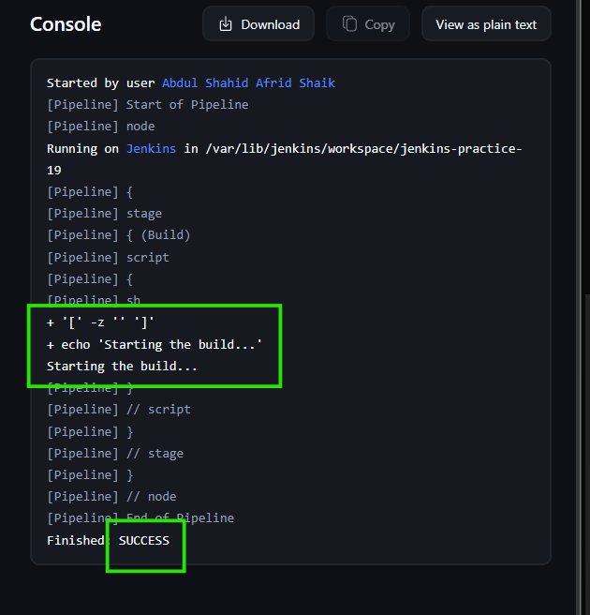

Task 9.3 — Groovy if-else

What we are learning
In the previous practical, the conditional logic was handled by the shell.
Here, we moved the conditional logic into Groovy, which is the language used for Jenkins Pipeline scripts.
The article demonstrates getting the environment variable through env.SKIP_BUILD and then using Groovy if-else. Pasted text

Pipeline Script
pipeline {
agent any

stages {
stage('Build') {
steps {
script {
def skipBuild = env.SKIP_BUILD

if (skipBuild == null || skipBuild.isEmpty()) {
echo 'Starting the build...'
} else {
echo 'Skipping the build...'
}
}
}
}
}
}

Understanding the Script
First we get the environment variable:
def skipBuild = env.SKIP_BUILD
Then we check:
if (skipBuild == null || skipBuild.isEmpty())
This means:
- If skipBuild is null
- OR
- If skipBuild is empty
then the build starts.
Otherwise, the build is skipped.

Why script {}?
In a Declarative Pipeline, normal Groovy programming logic such as if-else is placed inside:
script {
...
}

Expected Output
Starting the build...
Finished: SUCCESS

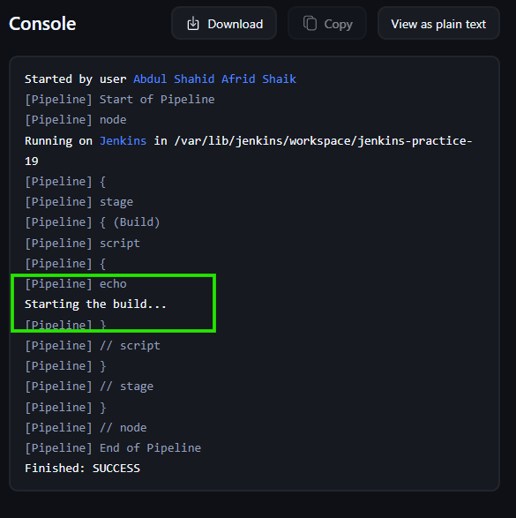

Task 9.4 — Groovy Ternary Operator

What we are learning
In this practical, we learned another way to write conditional logic using the ternary operator.
The ternary operator is a short form of if-else. The article demonstrates it inside the Groovy script block. Pasted text

Pipeline Script
pipeline {
agent any

stages {
stage('Build') {
steps {
script {
def skipBuild = env.SKIP_BUILD

(skipBuild == null || skipBuild.isEmpty()) ?
echo('Starting the build...') :
echo('Skipping the build...')
}
}
}
}
}

Ternary Syntax
The basic syntax is:
condition ? value-if-true : value-if-false
In our example:
(skipBuild == null || skipBuild.isEmpty()) ?
echo('Starting the build...') :
echo('Skipping the build...')
means:
If skipBuild is empty or null, start the build; otherwise skip it.

Expected Output
Starting the build...
Finished: SUCCESS

Task 9.5 — Scripted Pipeline With sh

What we are learning
Until now, we were mainly using Declarative Pipelines.
Here we learned how to write the same conditional logic using a Scripted Pipeline.
The article explains that Scripted Pipelines use a different structure and provide more flexibility for Groovy code. Pasted text

Declarative Pipeline Structure
We previously used:
pipeline {
agent any

stages {
stage('Build') {
steps {
...
}
}
}
}

Scripted Pipeline Structure
Now we use:
node {
stage('Build') {
...
}
}

Pipeline Script
node {
stage('Build') {
sh '''
test -z "$SKIP_BUILD" && echo "Starting the build..."
'''
}
}

Understanding the Script
The important difference is the overall Pipeline structure.
Instead of:
pipeline {
agent any
we use:
node {
The shell condition itself remains the same:
test -z "$SKIP_BUILD" && echo "Starting the build..."

Expected Output
Starting the build...
Finished: SUCCESS

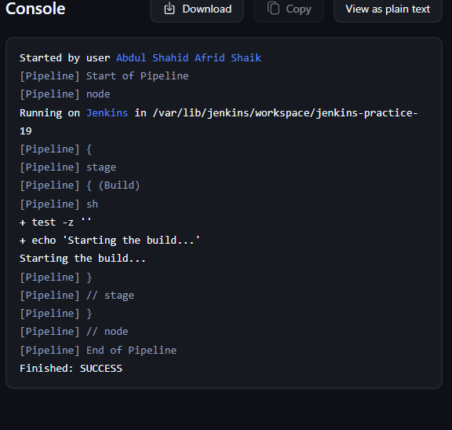

Task 9.6 — Scripted Pipeline With Groovy if-else

What we are learning
In this practical, we learned how to use Groovy if-else directly inside a Scripted Pipeline.
Unlike Declarative Pipeline, we don't need the script {} block for this Groovy logic in a Scripted Pipeline. The article specifically points out this difference. Pasted text

Pipeline Script
node {
stage('Build') {
def skipBuild = env.SKIP_BUILD

if (skipBuild == null || skipBuild.isEmpty()) {
echo 'Starting the build...'
} else {
echo 'Skipping the build...'
}
}
}

Understanding the Script
First:
def skipBuild = env.SKIP_BUILD
gets the value of the environment variable.
Then:
if (skipBuild == null || skipBuild.isEmpty())
checks whether it is not defined or empty.
If true:
echo 'Starting the build...'
If false:
echo 'Skipping the build...'

Important Difference
Declarative Pipeline:
steps {
script {
if (...) {
...
}
}
}
Scripted Pipeline:
stage('Build') {
if (...) {
...
}
}
No script {} is required in the Scripted Pipeline.

404 Error Encountered
While opening/running this practical, Jenkins showed:
Oops!

Not Found

This page may not exist, or you may not have permission to see it.
This was a Jenkins page/navigation issue, not a Pipeline syntax error.
We returned to:
Jenkins Dashboard
→ jenkins-practice-19
→ Configure
→ Pipeline
and verified the Scripted Pipeline.
After returning to the job and running it again, the practical was completed successfully.

Expected Output
Starting the build...
Finished: SUCCESS

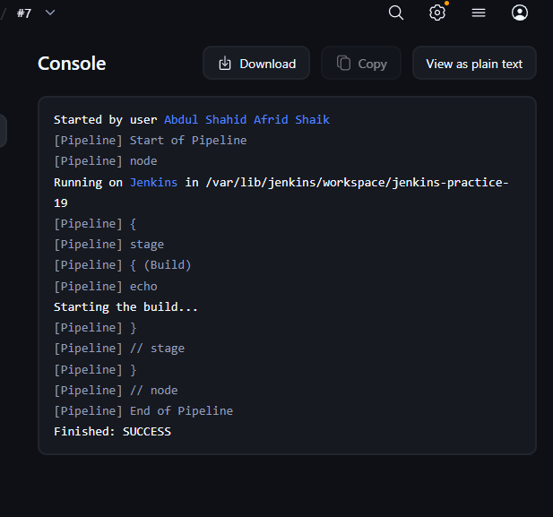

Task 9.7 — when Directive

What we are learning
The when directive allows Jenkins to decide whether a stage should execute based on a condition.
This is useful when we want to conditionally run an entire stage rather than putting an if-else around individual commands. The article introduces when specifically for this purpose. Pasted text

Pipeline Script
pipeline {
agent any

stages {
stage('Build') {
when {
expression {
def skipBuild = env.SKIP_BUILD
return skipBuild == null || skipBuild.isEmpty()
}
}

steps {
echo 'Starting the build...'
}
}
}
}

Understanding the Script
The condition is inside:
when {
expression {
...
}
}
We get the variable:
def skipBuild = env.SKIP_BUILD
Then return the condition:
return skipBuild == null || skipBuild.isEmpty()
If the condition is true, Jenkins executes the Build stage.
If the condition is false, Jenkins skips the Build stage.

Expected Result
Since SKIP_BUILD was not defined:
Starting the build...
Finished: SUCCESS

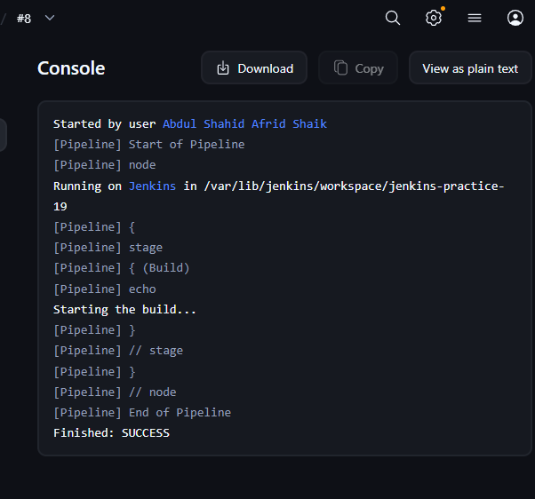

Important Concepts Learned

1. Shell test
test -z "$SKIP_BUILD"
Checks whether the variable is empty.

2. Shell if-else
if [ -z "$SKIP_BUILD" ]
then
echo "Starting the build..."
else
echo "Skipping the build..."
fi
Conditional logic is handled by the shell.

3. Groovy if-else
if (condition) {
...
} else {
...
}
Conditional logic is handled by Groovy.

4. Ternary Operator
condition ? valueIfTrue : valueIfFalse
A shorter form of if-else.

5. Declarative Pipeline
Basic structure:
pipeline {
agent any

stages {
stage('Build') {
steps {
...
}
}
}
}

6. Scripted Pipeline
Basic structure:
node {
stage('Build') {
...
}
}

7. when Directive
stage('Build') {
when {
expression {
return condition
}
}

steps {
...
}
}
It controls whether a complete stage should execute.

Final Task 9 Result
We successfully practiced 7 conditional approaches:
Practical | Concept | Result
9.1 | sh + test | ✅
9.2 | Shell if-else | ✅
9.3 | Groovy if-else | ✅
9.4 | Groovy ternary | ✅
9.5 | Scripted Pipeline + sh | ✅
9.6 | Scripted Pipeline + Groovy if-else | ✅
9.7 | when directive | ✅
Task 9 completed successfully.

_________________________________________________________________________________________

>> Skip a Stage in a Jenkins Pipeline

Task 10 — Skip a Stage in a Jenkins Pipeline

Objective
In this task, we learned different ways to skip a stage in a Jenkins Pipeline.
The article explains that skipping stages can reduce pipeline execution time when certain stages are unnecessary. It presents three approaches:
- Using the when directive
- Using the input step
- Using a function to control pipeline flow

Task 10.1 — Skip a Stage Using when Directive

What we are learning
We learned how to conditionally execute an entire stage using the Jenkins when directive.
We used a Boolean parameter called:
skip_test
Its behavior is:
false → Test stage runs
true → Test stage is skipped

Jenkins Job
Job name:
jenkins-practice-20
Job type:
Pipeline

Pipeline Script
pipeline {
agent any

parameters {
booleanParam(
name: 'skip_test',
defaultValue: false,
description: 'Set to true to skip the test stage'
)
}

stages {
stage('Build') {
steps {
sh 'echo "Building application"'
}
}

stage('Test') {
when {
expression {
params.skip_test != true
}
}

steps {
sh 'echo "Testing application"'
}
}

stage('Deploy') {
steps {
sh 'echo "Deploying application"'
}
}
}
}

Understanding the Script
The parameter is created using:
booleanParam(
name: 'skip_test',
defaultValue: false,
description: 'Set to true to skip the test stage'
)
This creates a checkbox in Build with Parameters.
The Test stage contains:
when {
expression {
params.skip_test != true
}
}
This controls whether the Test stage executes.

When skip_test = false
The condition becomes:
false != true
which is true.
Therefore:
Build
↓
Test
↓
Deploy
Expected output:
Building application
Testing application
Deploying application
Finished: SUCCESS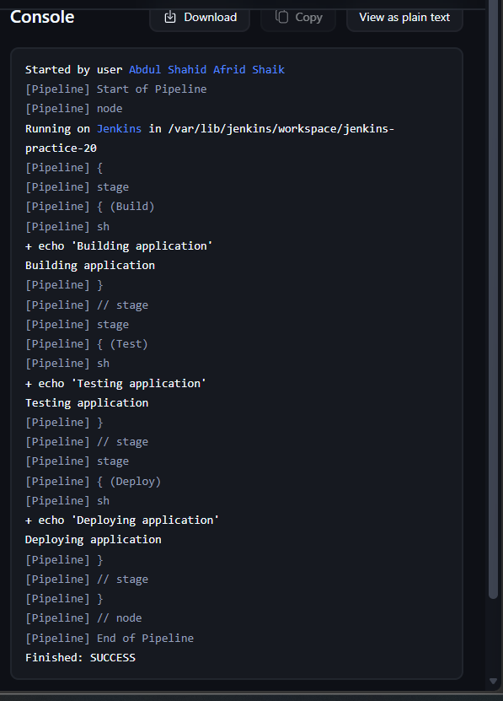

When skip_test = true
The condition becomes:
true != true
which is false.
Therefore:
Build
↓
Test — SKIPPED
↓
Deploy
The Test stage is skipped.

What we learned
The when directive allows us to decide whether a complete stage should execute based on a condition.
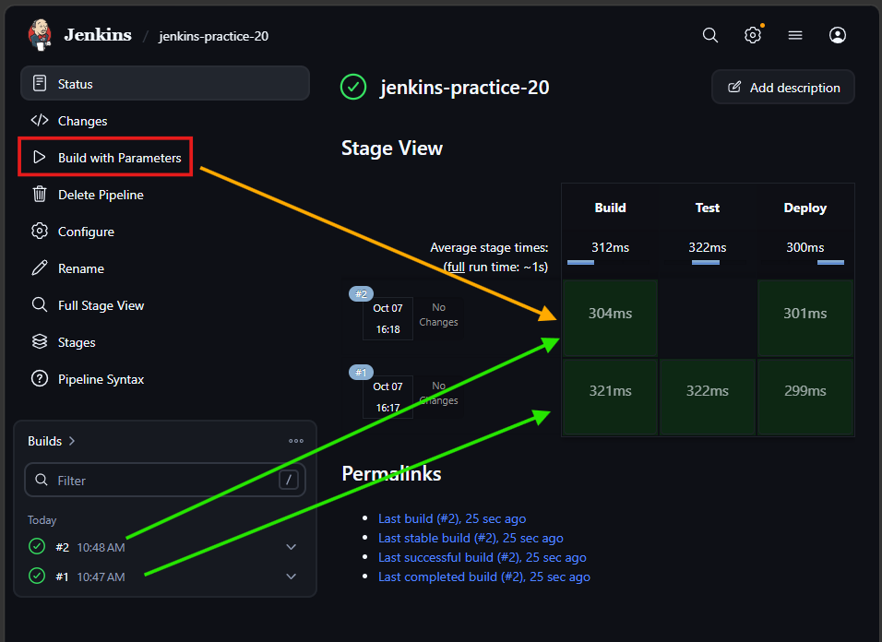

Task 10.2 — Skip a Stage Using input Step

What we are learning
We learned how the Jenkins input step can pause a Pipeline and wait for user input.
This approach allows a user to make a decision while the Pipeline is running.
The article uses an input prompt in the Test stage to determine whether testing should be skipped.

Pipeline Used
The important structure was:
stage('Test') {
steps {
input(
message: 'Want to skip the test stage?',
ok: 'Continue',
parameters: [
booleanParam(
name: 'skip_test',
defaultValue: false
)
]
)

script {
if (params.skip_test) {
echo 'Skipping the test stage'
return
}

sh 'echo "Testing the application"'
}
}
}

What happens
When Jenkins reaches:
Test
the Pipeline pauses.
Jenkins waits for the user to provide input.
The user can select:
skip_test

Parameter Meaning
☐ Unchecked:
skip_test = false
→ Run the Test steps.
☑ Checked:
skip_test = true
→ Skip the Test steps.
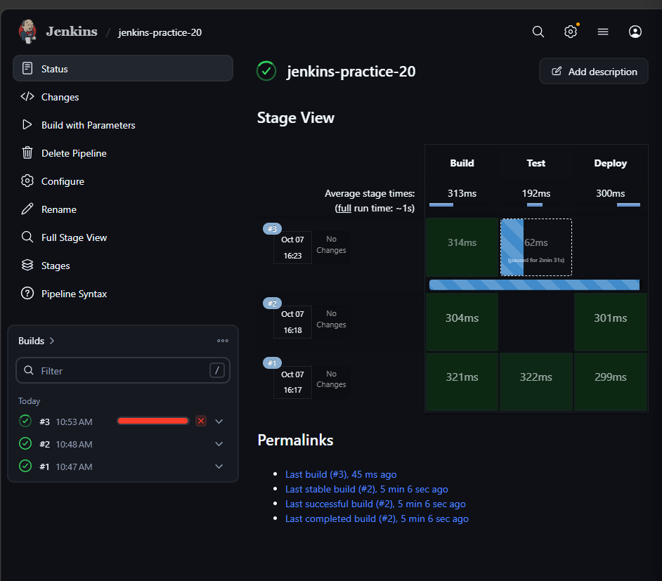

Error Encountered
While testing this practical, the Pipeline correctly paused at the Test stage.
The Jenkins Stage View showed:
Build → Test (paused) → Deploy
However, when we attempted to interact with the paused input, Jenkins returned:
Oops!

Not Found

This page may not exist, or you may not have permission to see it.

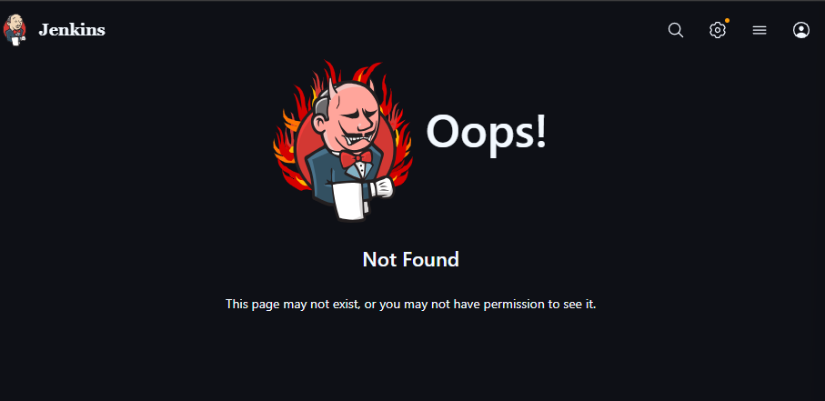

Resolution / Handling
The issue was with the Jenkins input-page/navigation behavior, not with the basic concept of the input step.
We did not continue repeatedly rebuilding the same practical. We moved on to the remaining method from the article.

What we learned
The important concept is:
input(...)
It allows Jenkins to:
- Pause the Pipeline
- Ask the user for input
- Continue the Pipeline based on the user's decision
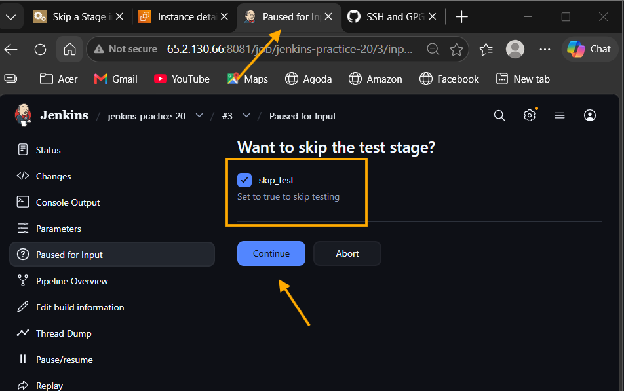

Task 10.3 — Using a Function to Control Pipeline Flow

What we are learning
The third approach is to create a reusable function that controls whether a stage's steps should execute.
This is useful when several stages need similar skip logic.
Instead of repeatedly writing the same if-else logic, we create one function and reuse it.

Pipeline Script
pipeline {
agent any

parameters {
booleanParam(
name: 'skip_test',
defaultValue: false,
description: 'Set to true to skip the test stage'
)
}

stages {
stage('Build') {
steps {
sh 'echo "Building the application"'
}
}

stage('Test') {
steps {
execute_stage('Test', params.skip_test) {
sh 'echo "Running tests"'
}
}
}

stage('Deploy') {
steps {
sh 'echo "Deploying the application"'
}
}
}
}

def execute_stage(stage_name, skip, Closure steps) {
if (skip) {
echo "Skipping ${stage_name} stage"
} else {
steps.call()
}
}

Understanding the Script
The Test stage calls:
execute_stage('Test', params.skip_test) {
sh 'echo "Running tests"'
}
The function receives three things:

1. Stage name
'Test'

2. Skip value
params.skip_test
This is either:
true
or:
false

3. Steps to execute
{
sh 'echo "Running tests"'
}

Function Definition
The function is:
def execute_stage(stage_name, skip, Closure steps) {
if (skip) {
echo "Skipping ${stage_name} stage"
} else {
steps.call()
}
}

If skip = true
This condition becomes true:
if (skip)
So Jenkins executes:
echo "Skipping ${stage_name} stage"
Output:
Skipping Test stage
The test command is not executed.

If skip = false
The else block executes:
steps.call()
This calls the steps that were passed to the function:
sh 'echo "Running tests"'
Output:
Running tests

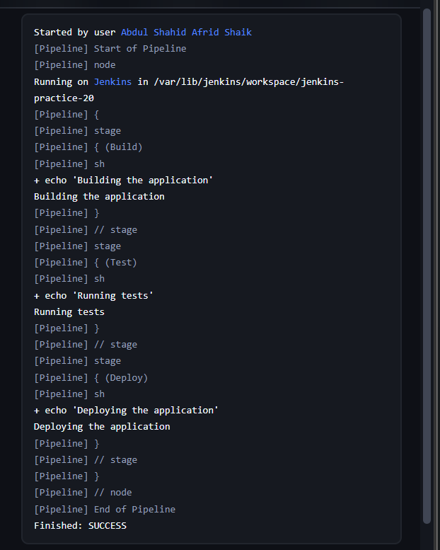

Testing the Function

skip_test = false
Leave the checkbox unchecked.
Pipeline flow:
Build
↓
Test
↓
Deploy
Expected output:
Building the application
Running tests
Deploying the application
Finished: SUCCESS

skip_test = true
Check:
☑ skip_test
Pipeline flow:
Build
↓
Test → Skipped
↓
Deploy
Expected output:
Building the application
Skipping Test stage
Deploying the application
Finished: SUCCESS

Important Concepts Learned

1. when Directive
Used when we want Jenkins to conditionally execute a stage.
when {
expression {
params.skip_test != true
}
}

2. input Step
Used when we want to pause the Pipeline and wait for a user's decision.
input(
message: 'Want to skip the test stage?',
ok: 'Continue'
)

3. Boolean Parameter
booleanParam(
name: 'skip_test',
defaultValue: false
)
The parameter gives us:
false → don't skip
true → skip

4. params
Jenkins provides the parameter value through:
params.skip_test
For example:
if (params.skip_test) {
...
}

5. Custom Function
We created:
def execute_stage(stage_name, skip, Closure steps)
This allows us to reuse the same stage-control logic.

6. Closure
The steps inside:
execute_stage('Test', params.skip_test) {
sh 'echo "Running tests"'
}
are passed to the function as a Groovy Closure.
The function executes them using:
steps.call()

Final Task 10 Result
Practical | Concept | Result
10.1 | when directive | ✅ Completed
10.2 | input step | ⚠️ Input page reached, Jenkins returned 404 when interacting
10.3 | Function to control pipeline flow | ✅ Completed

Final Understanding
There are three approaches we learned for controlling whether a stage runs:
when
↓
Condition decides whether the stage executes
input
↓
User makes a decision while Pipeline is paused
Function
↓
Reusable function decides whether the steps execute
Task 10 completed.

